**HUDSON CONFIG**

Table of Contents

Run Hudson as a Service 2

Views 3

Plugins: 9

Manage Hudson (Configure System): 12

Jobs: 16

1_AuthenticationServices 16

1_eStoreAdmin_UnInstall 20

2_eStoreAdminCSharp 26

3_eStoreAdmin_Install 31

4_eStoreAdmin_Test 34

ColorPicker 38

eStoreCSharp 41

FaceletsWARArchetype 45

FCKEditor 48

RichTextEditor 51

selenium-rc 54

Manage Nodes 57

# Run Hudson as a Service

java -jar hudson.war

Note: After Configure(ing) System, you need to create a slave node under Manage Hudson > Manage Nodes.

For Selenium Grid to pick up these slaves and register them you need to reboot.

# Views

# 

# 

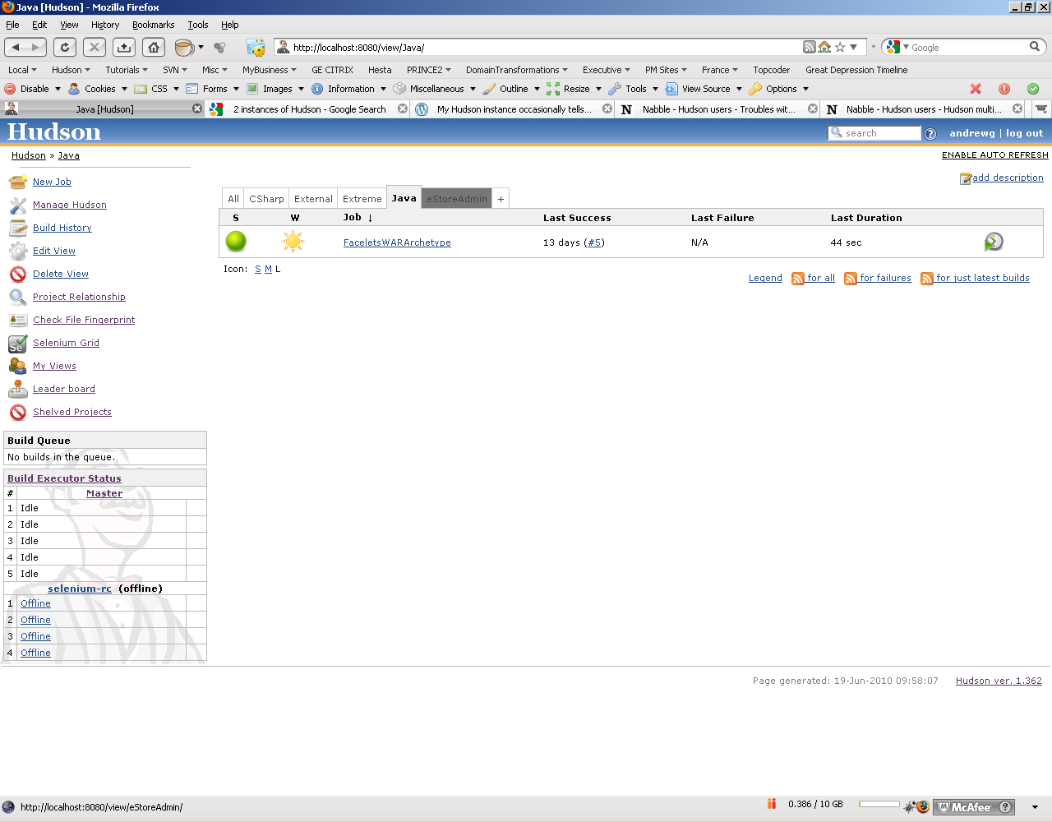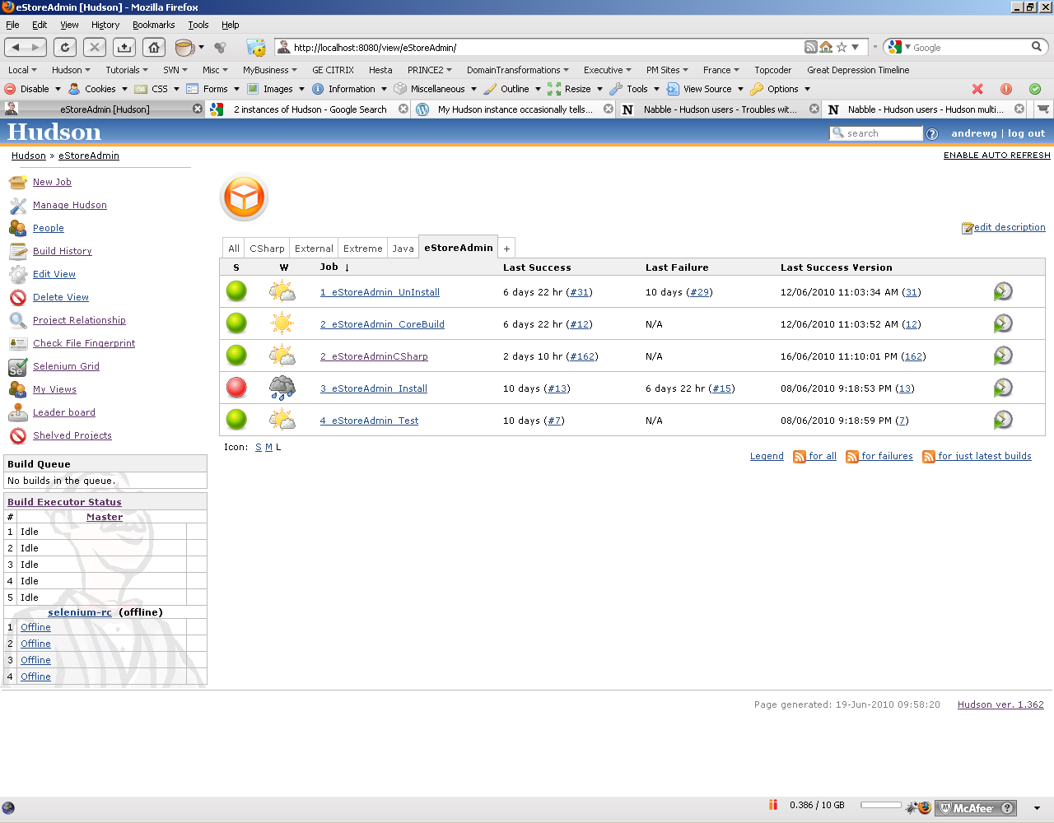

<img src="http://www.mywipstoreadmin.com.au/images/eStoreLogoTransparent.png"/>

# Plugins:

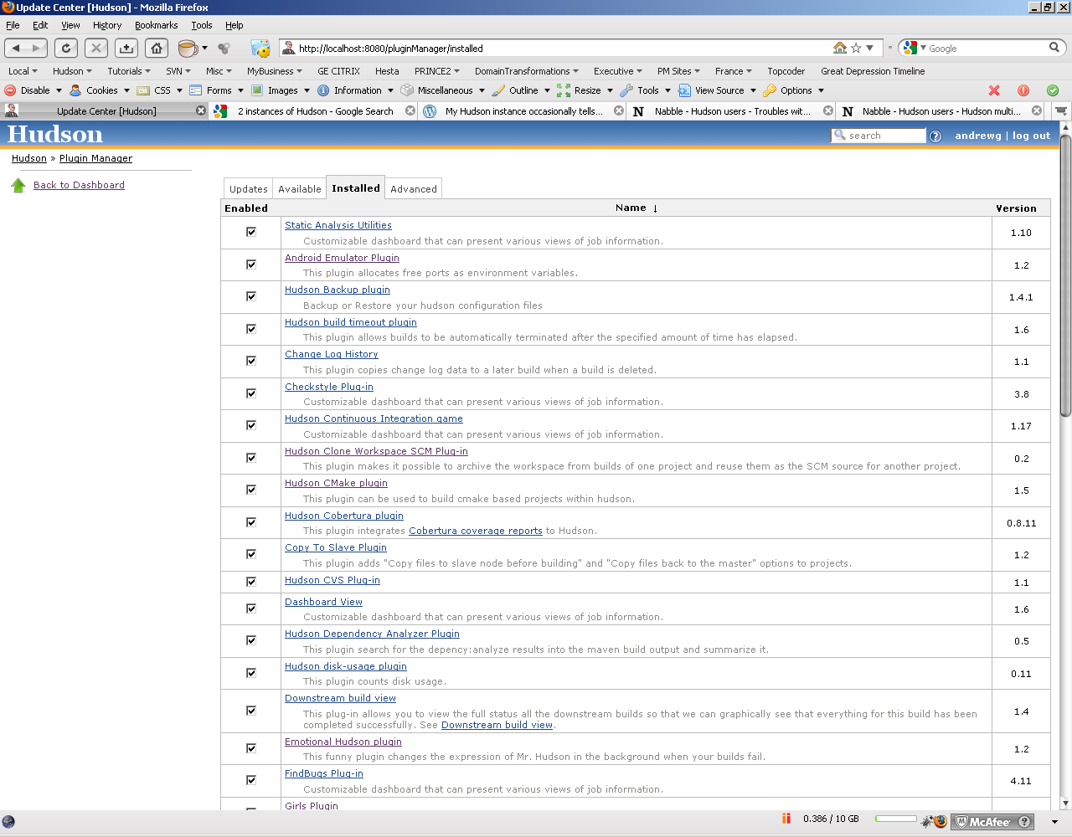

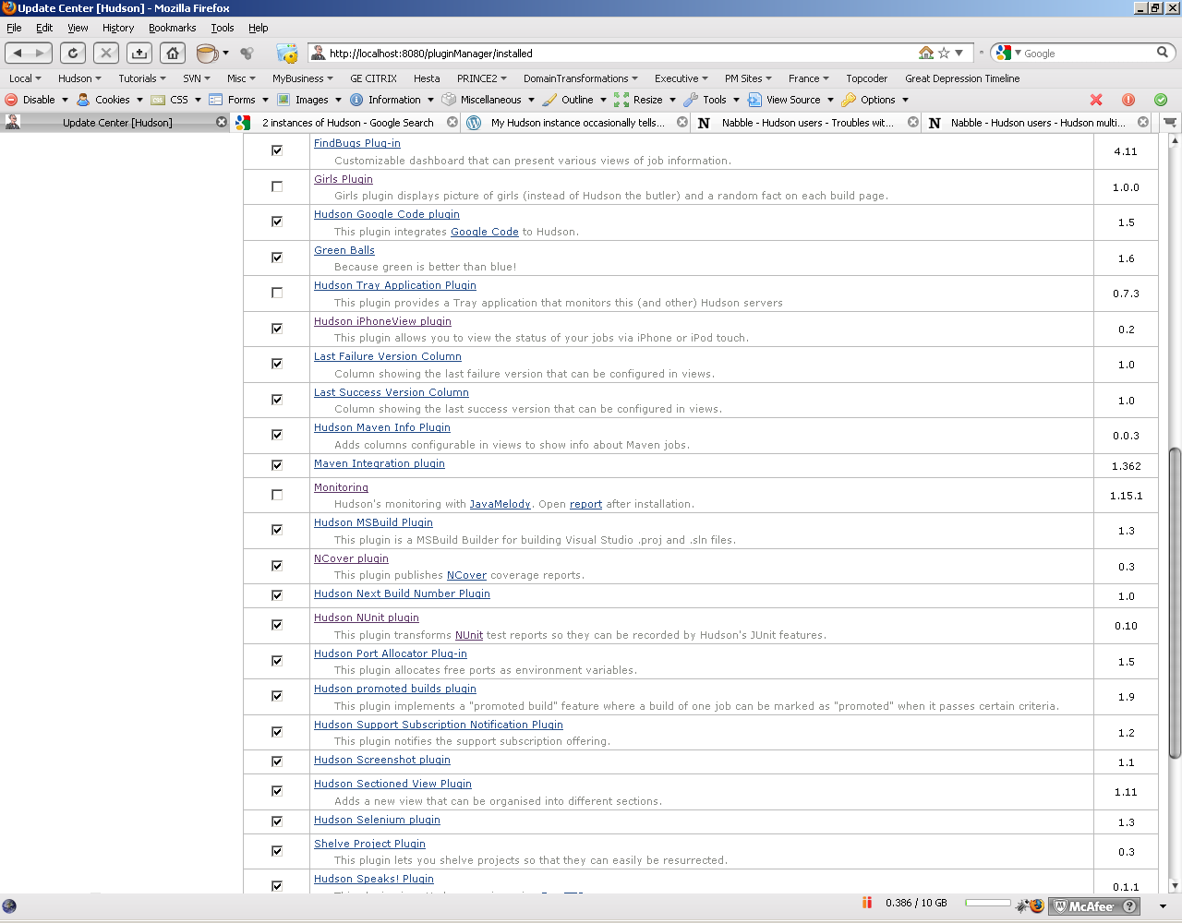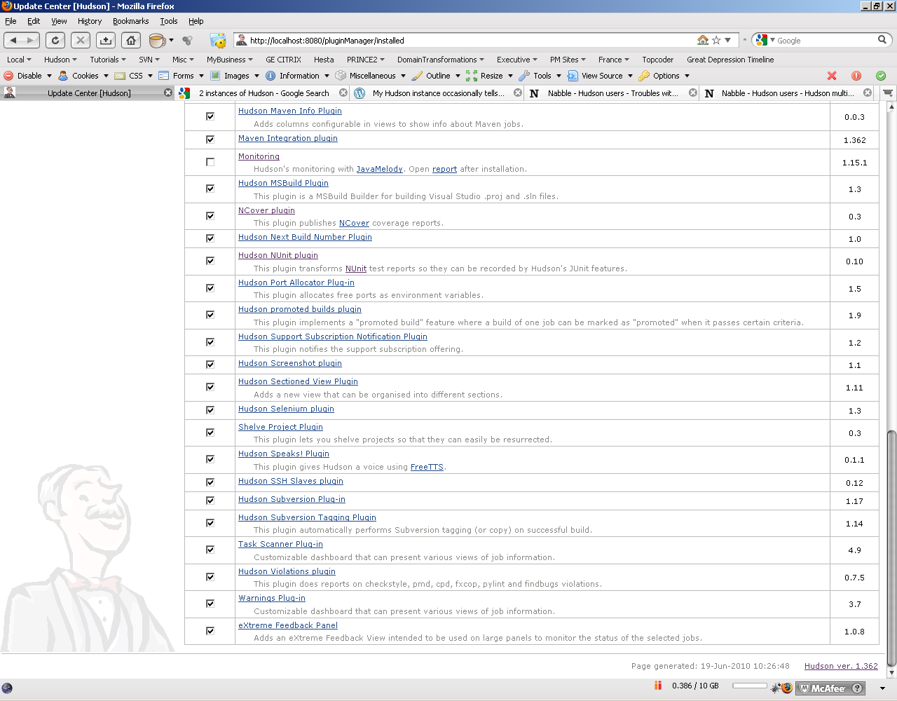

# Manage Hudson (Configure System):

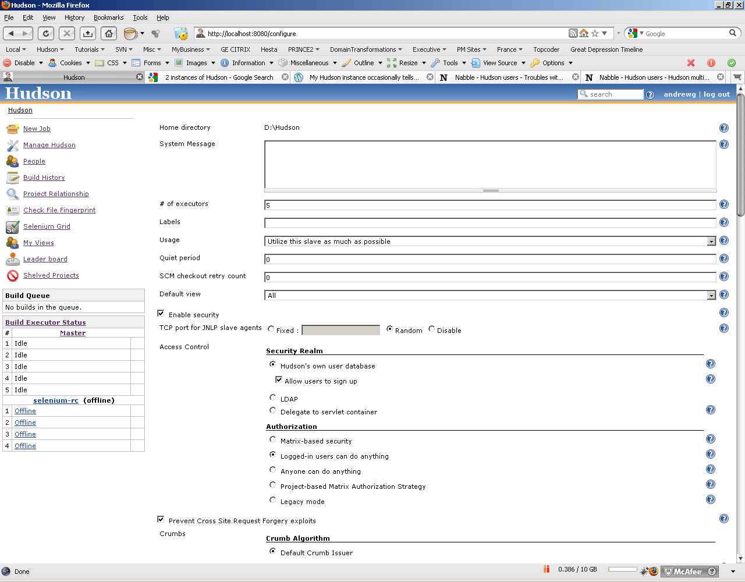

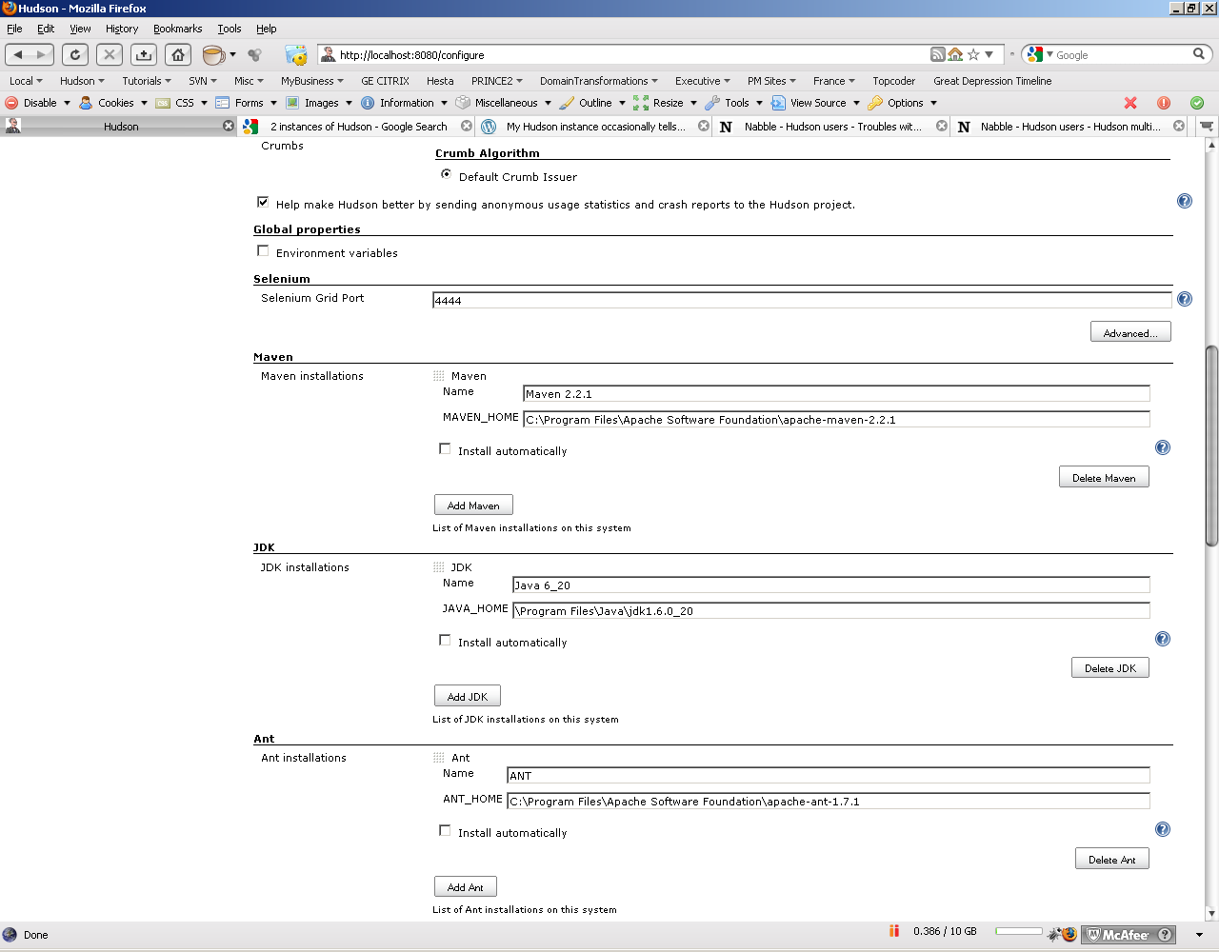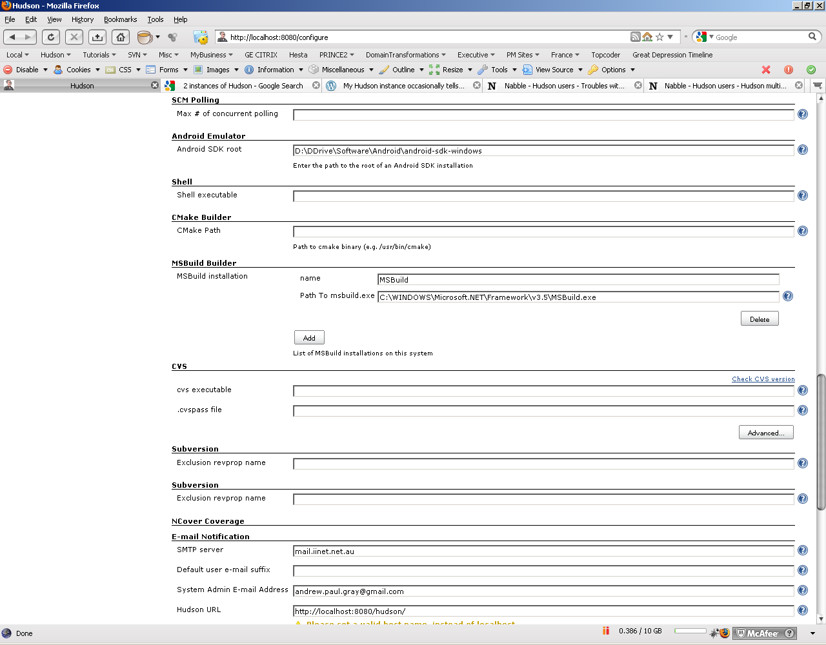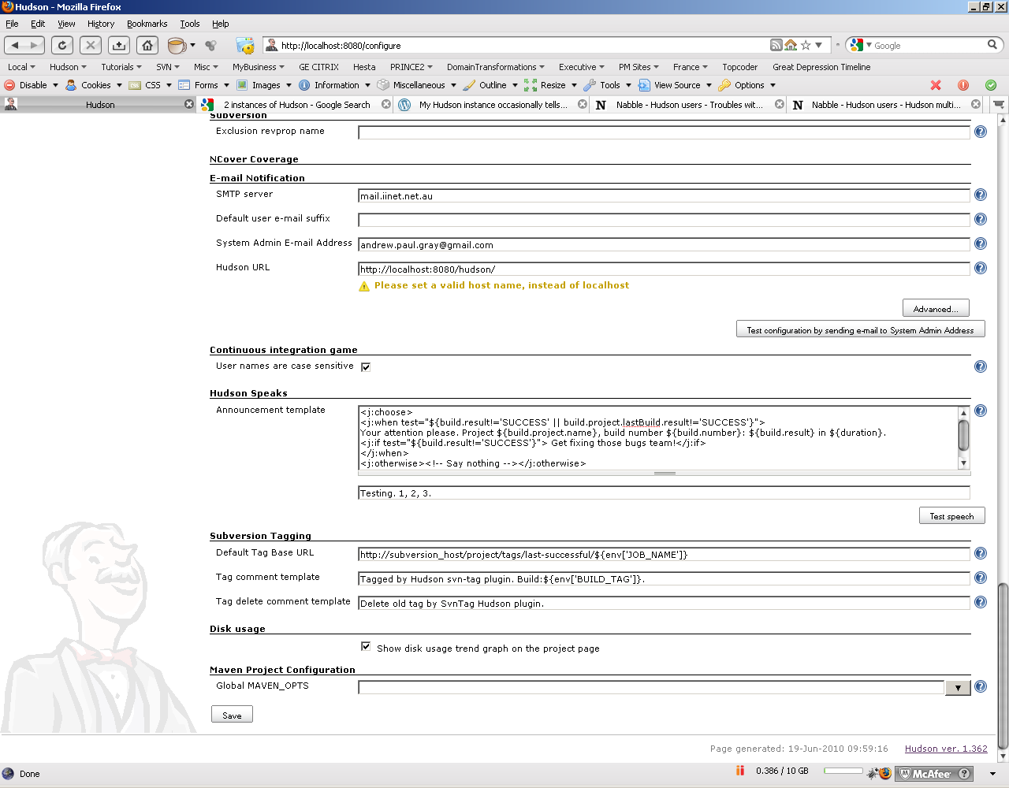

# Jobs:

# [1_AuthenticationServices](http://localhost:8080/job/1_AuthenticationServices/)

# 

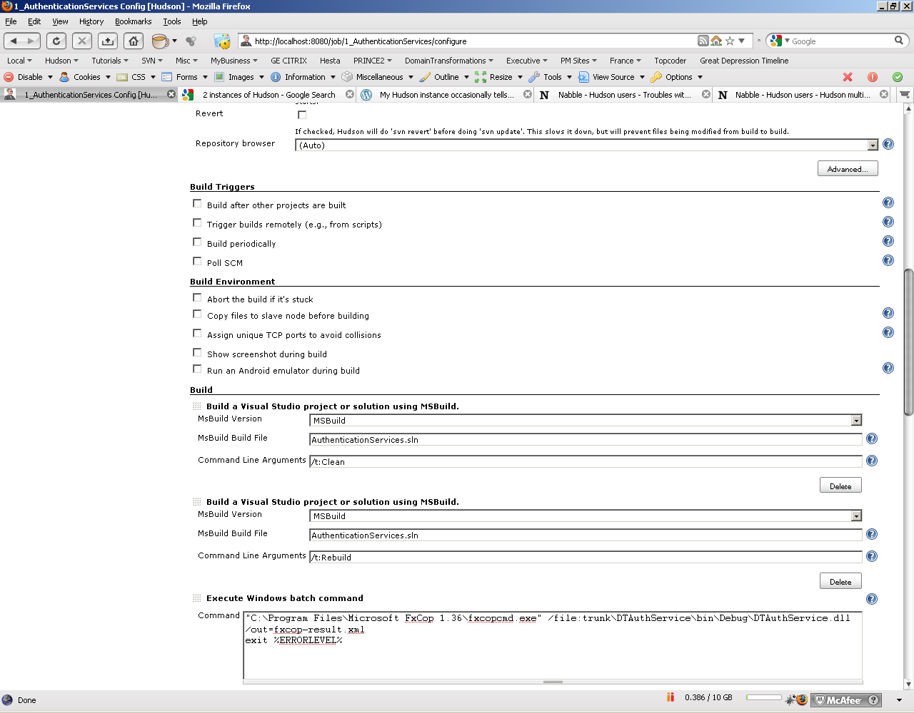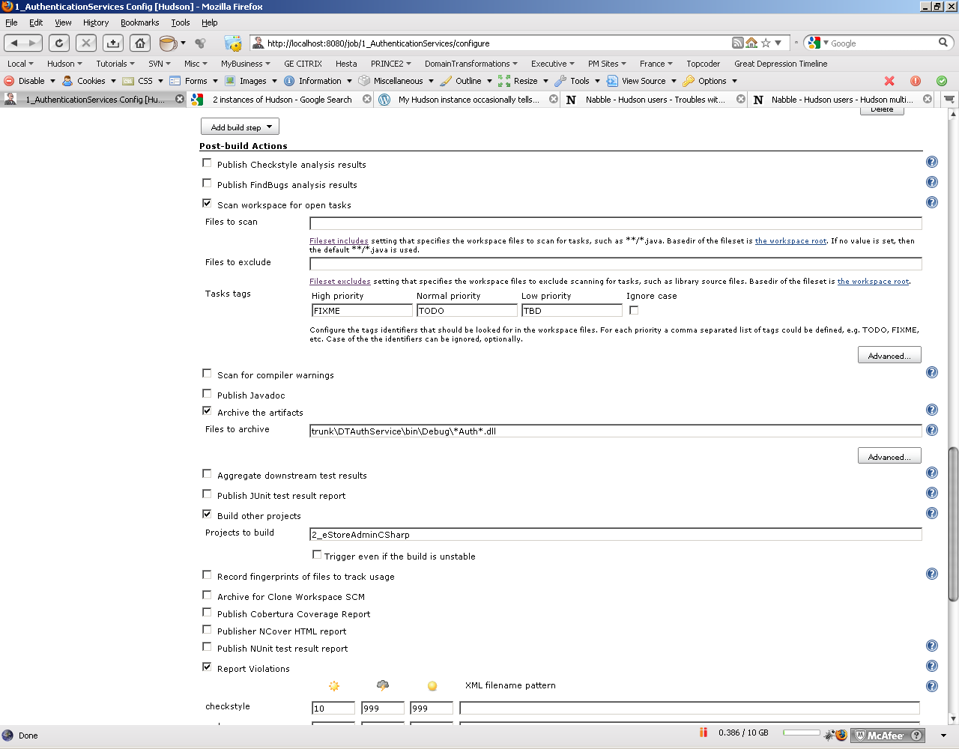 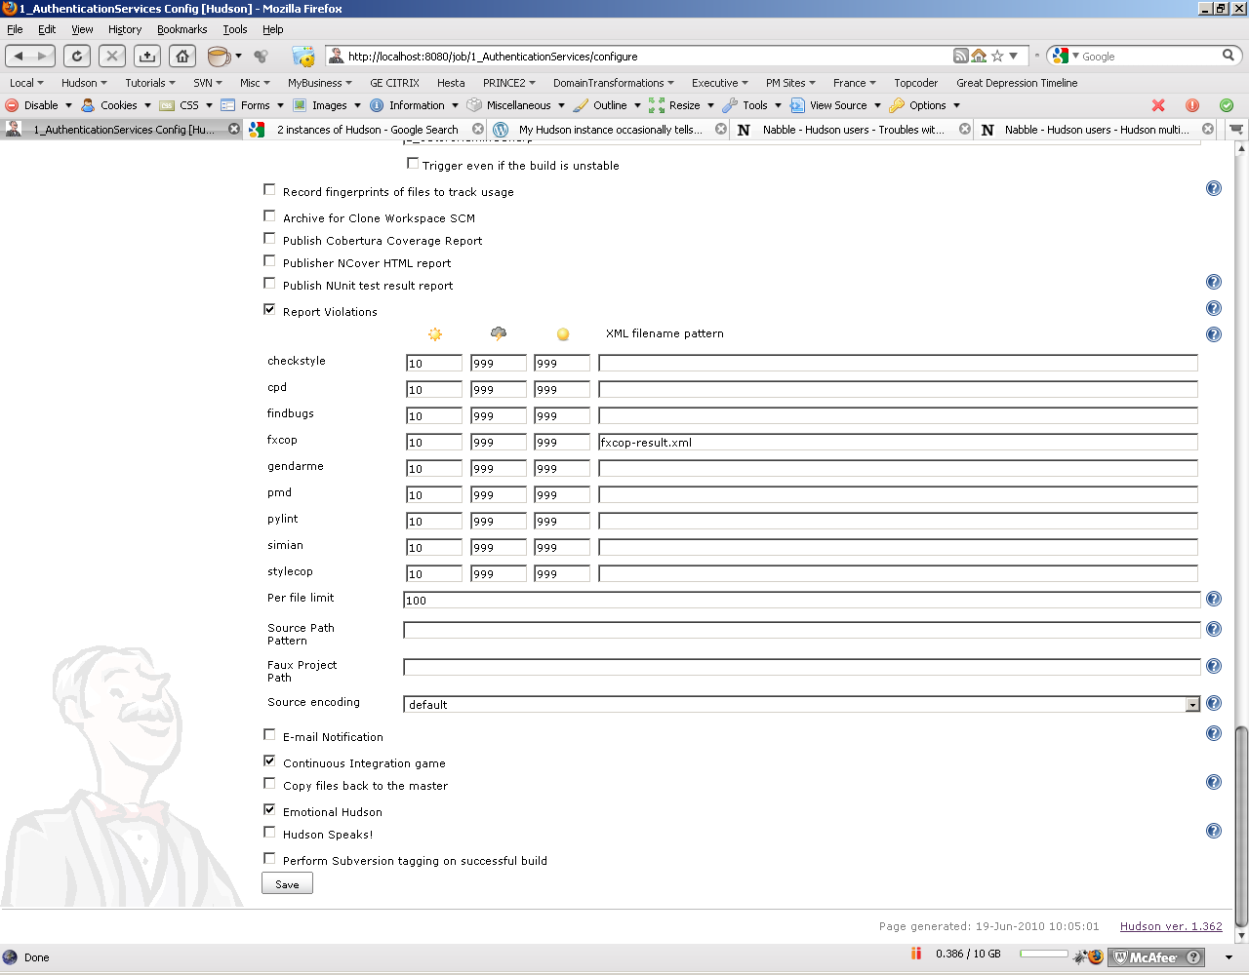

## 1_eStoreAdmin_UnInstall

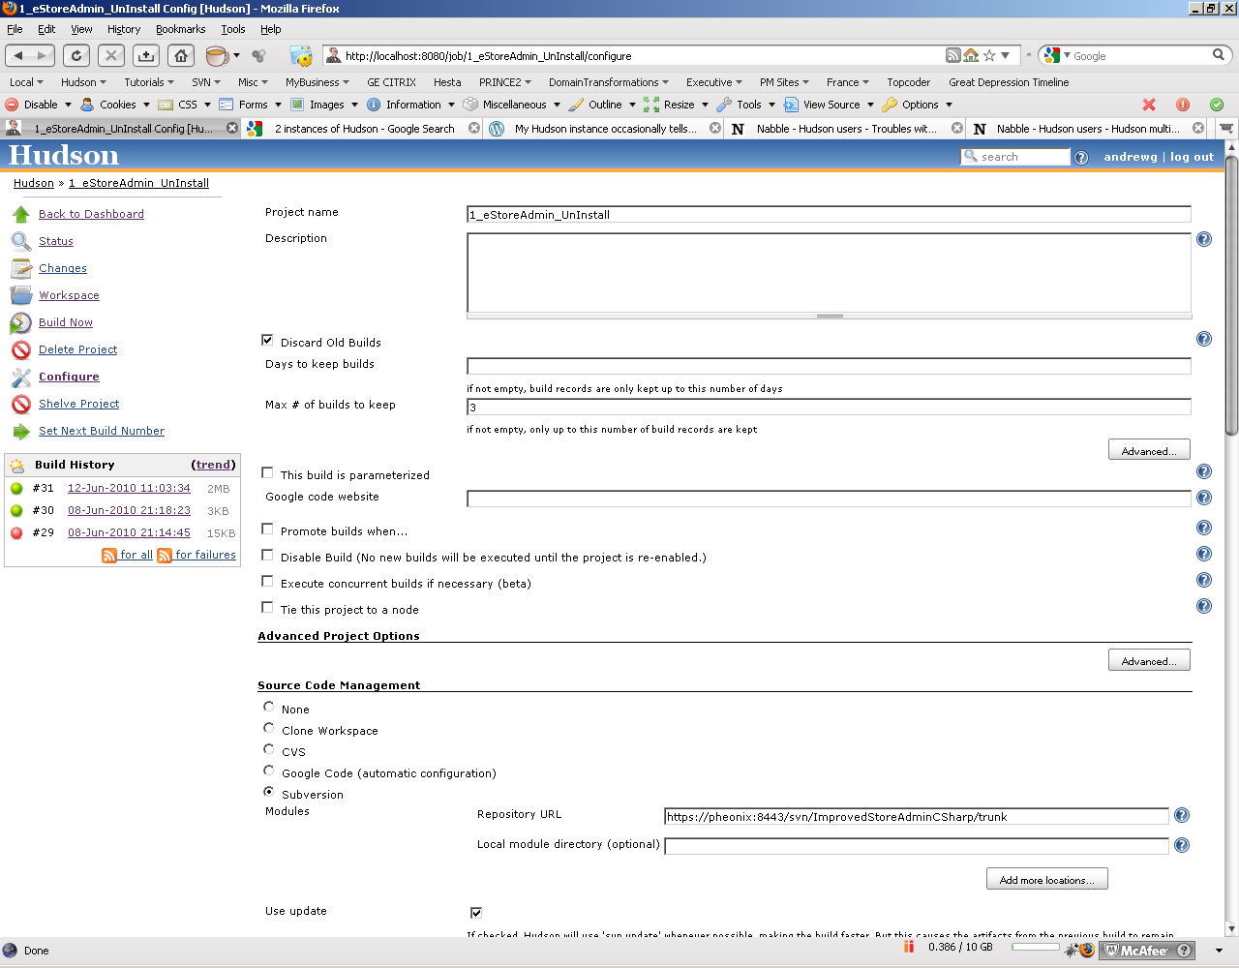

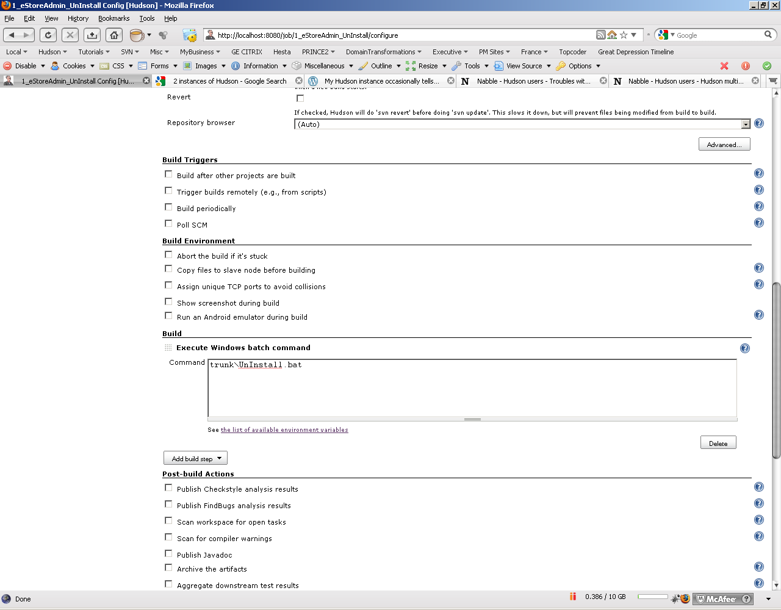 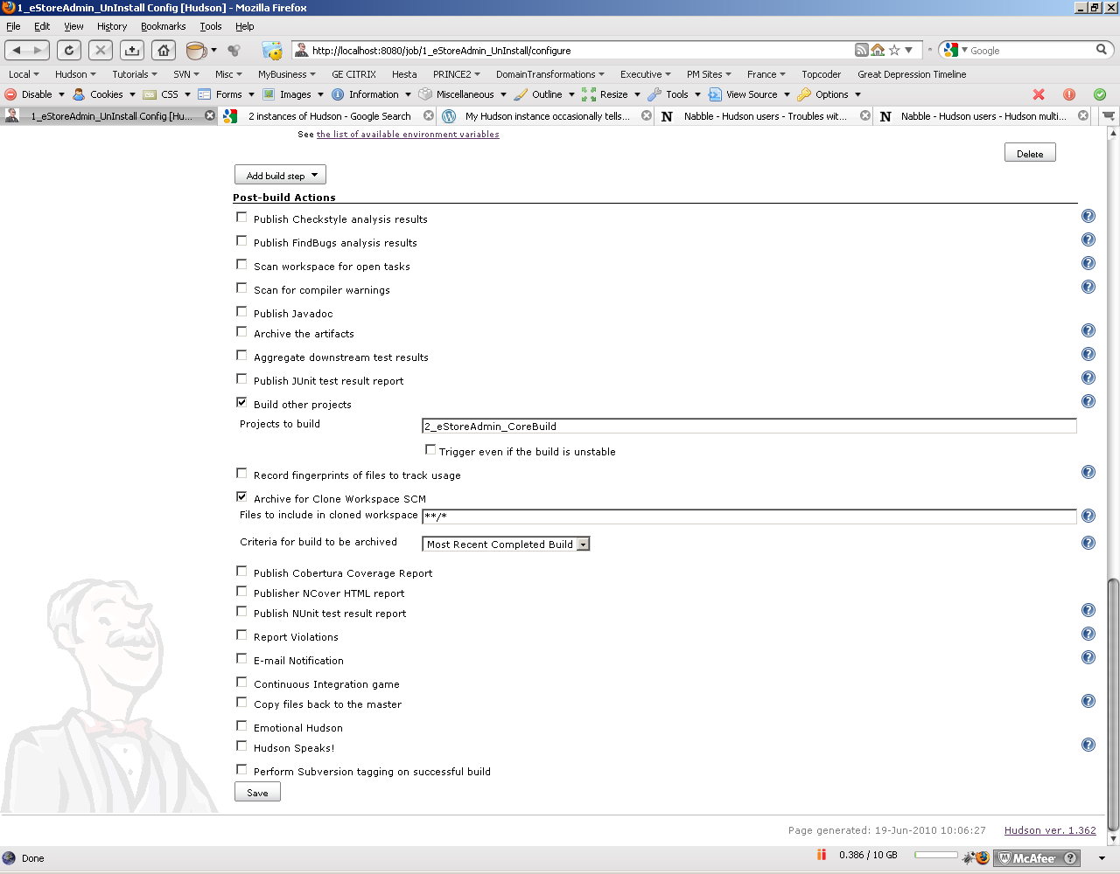 2_eStoreAdmin_CoreBuild

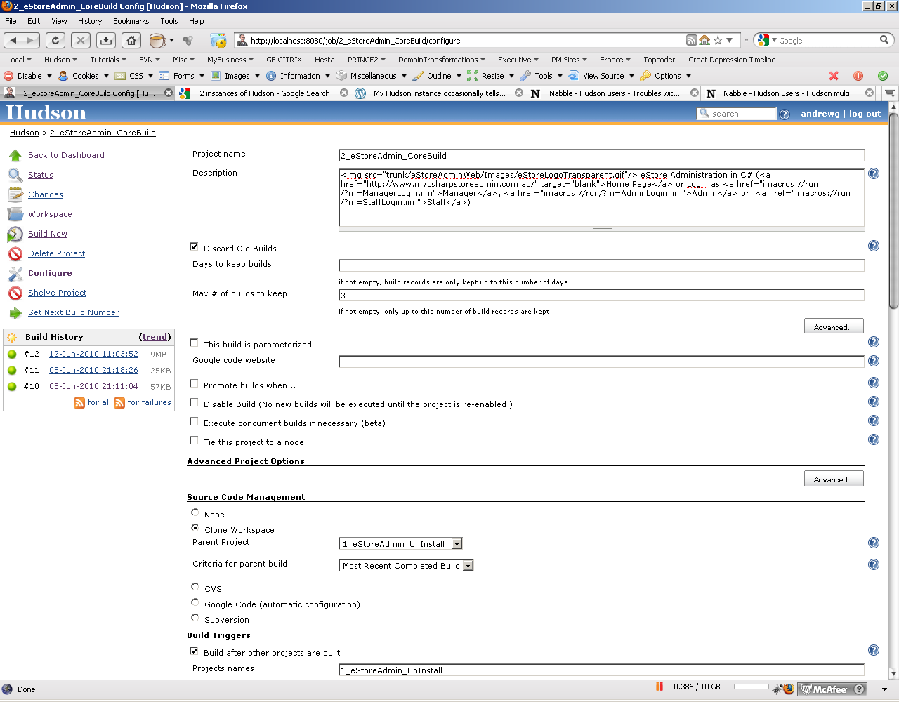

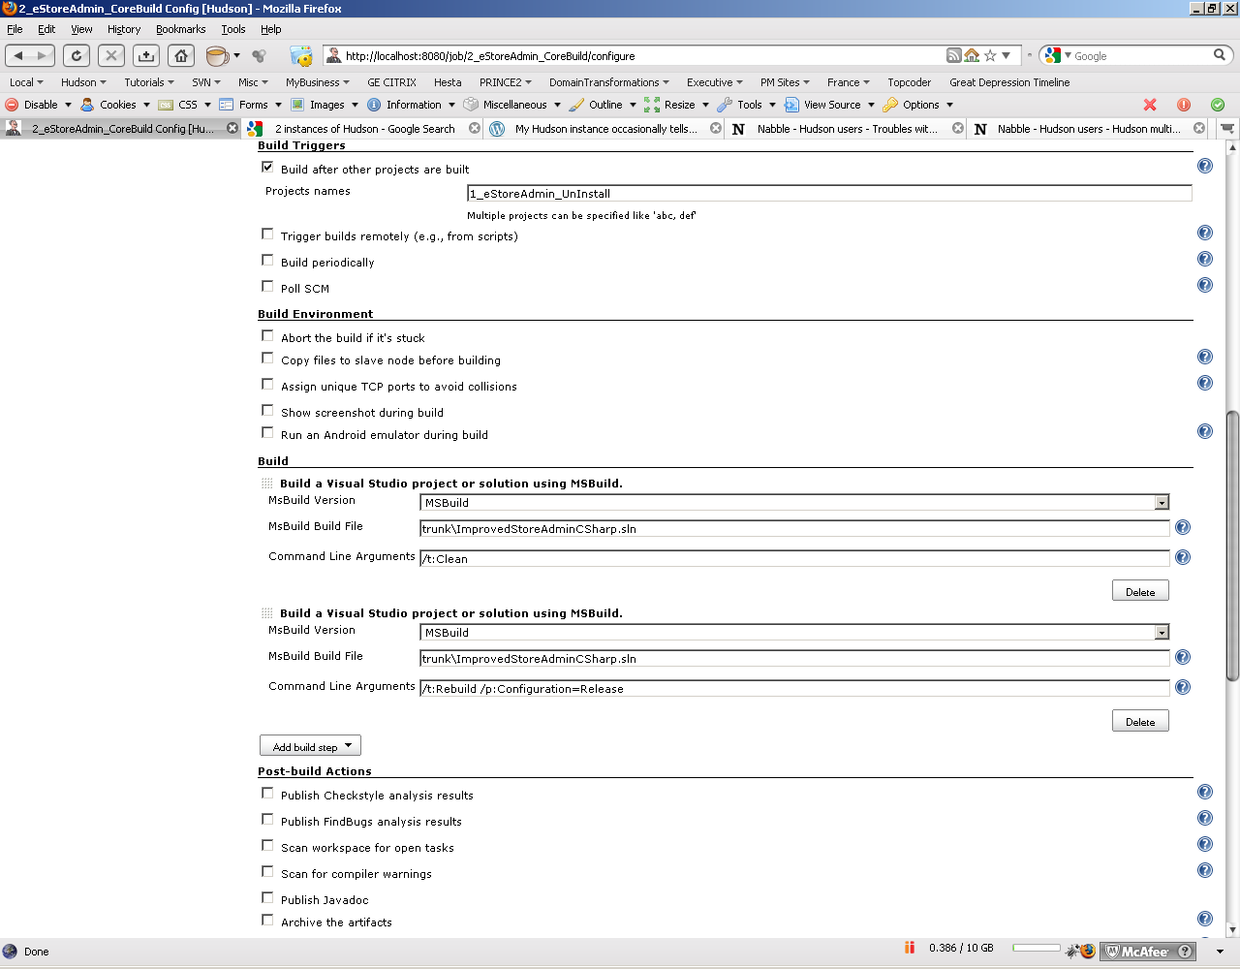 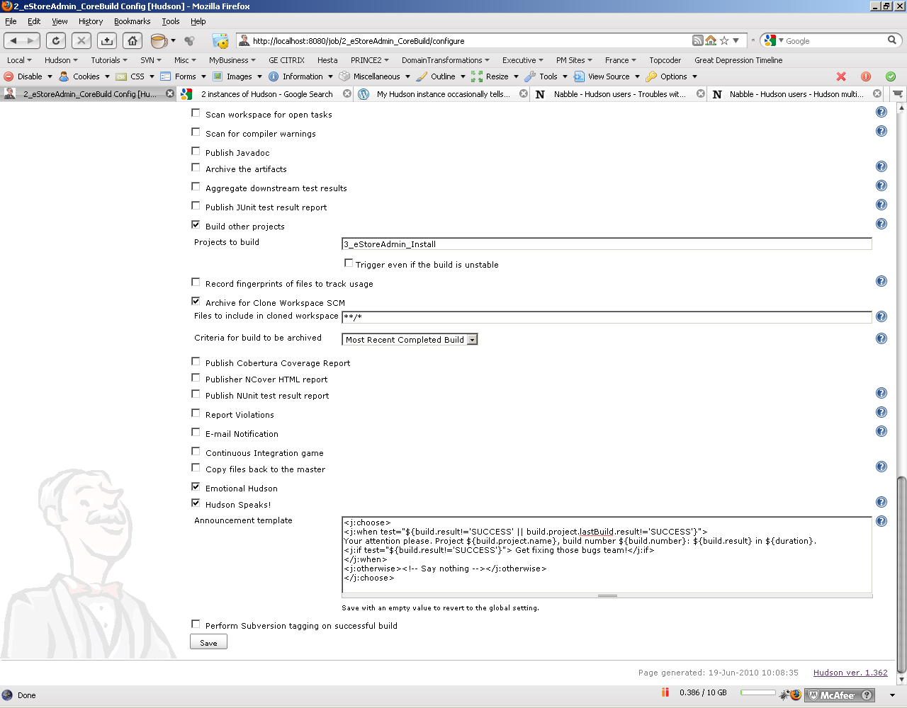

## 2_eStoreAdminCSharp

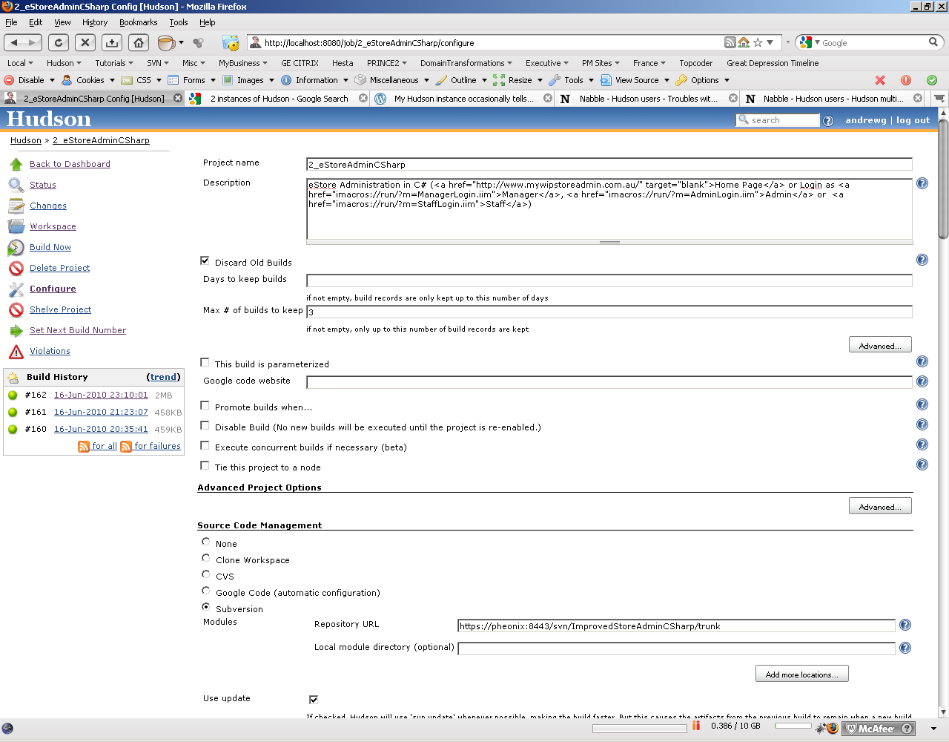

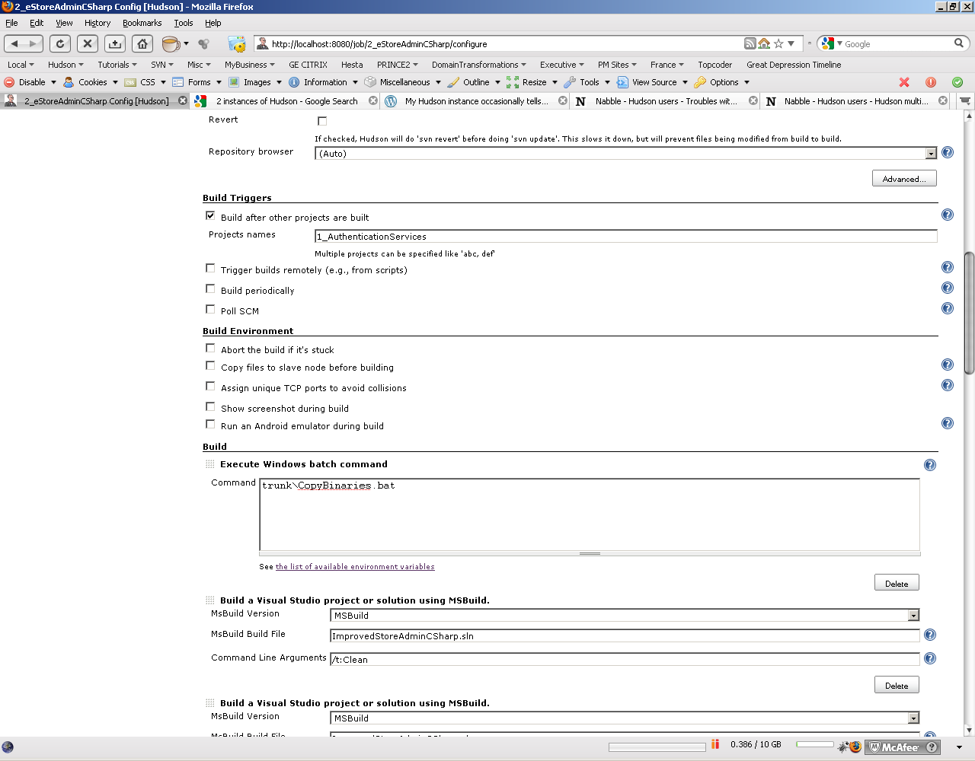

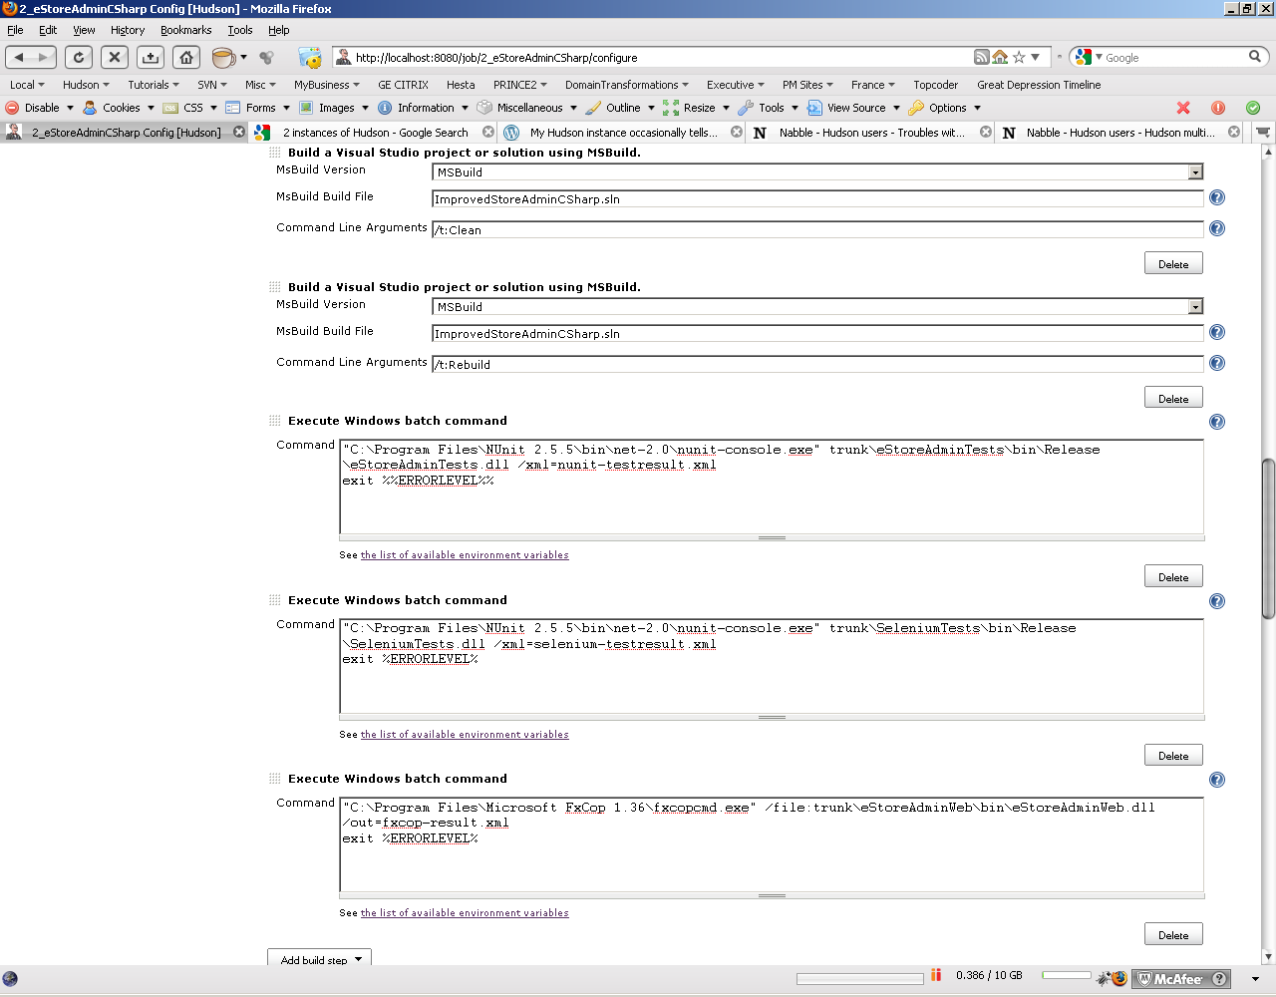 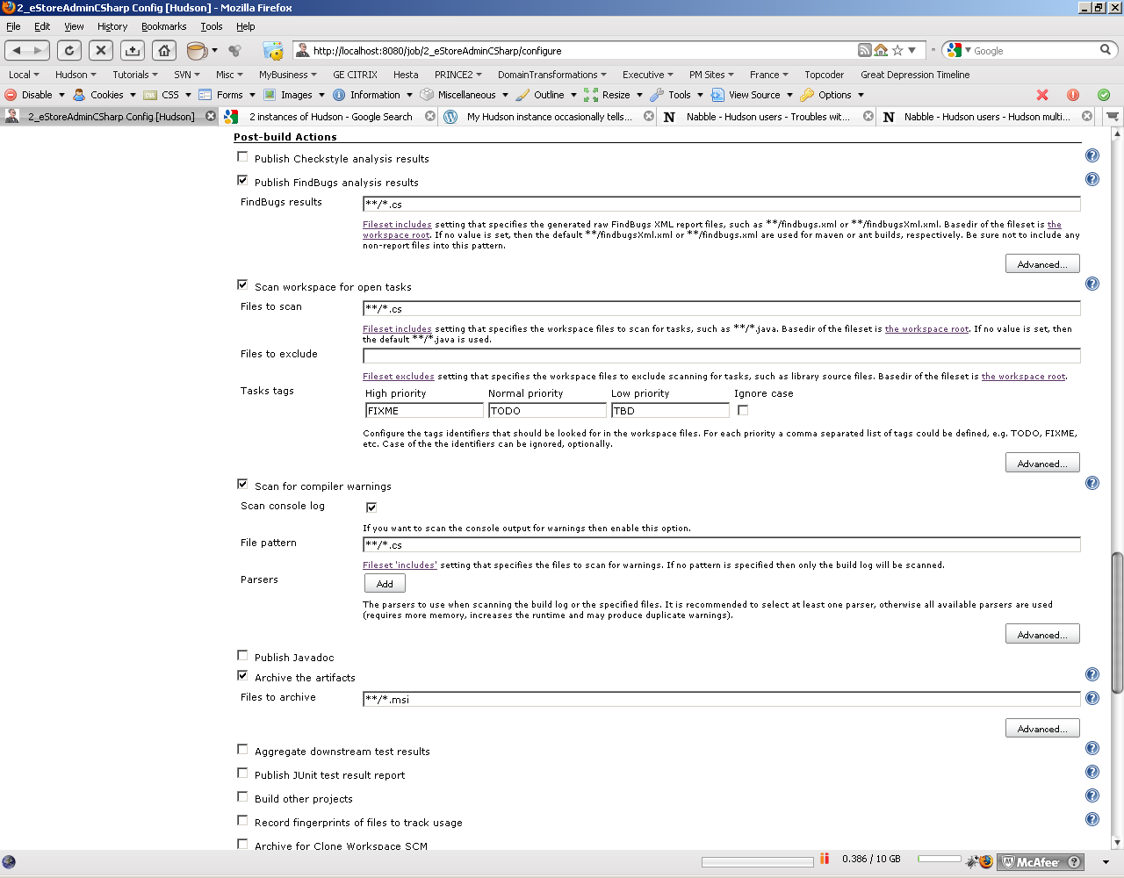

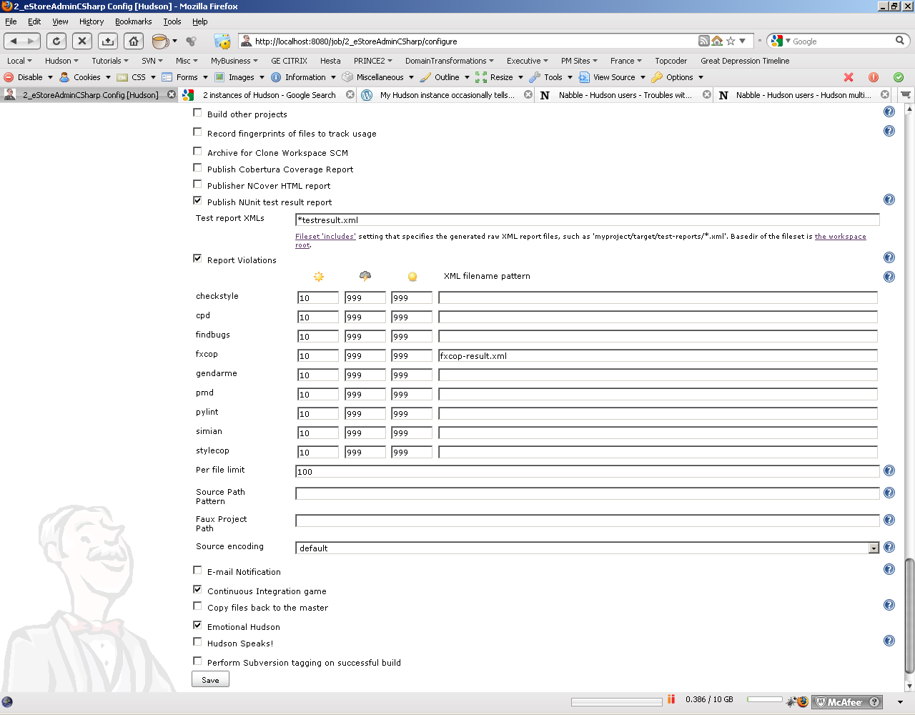

## 3_eStoreAdmin_Install

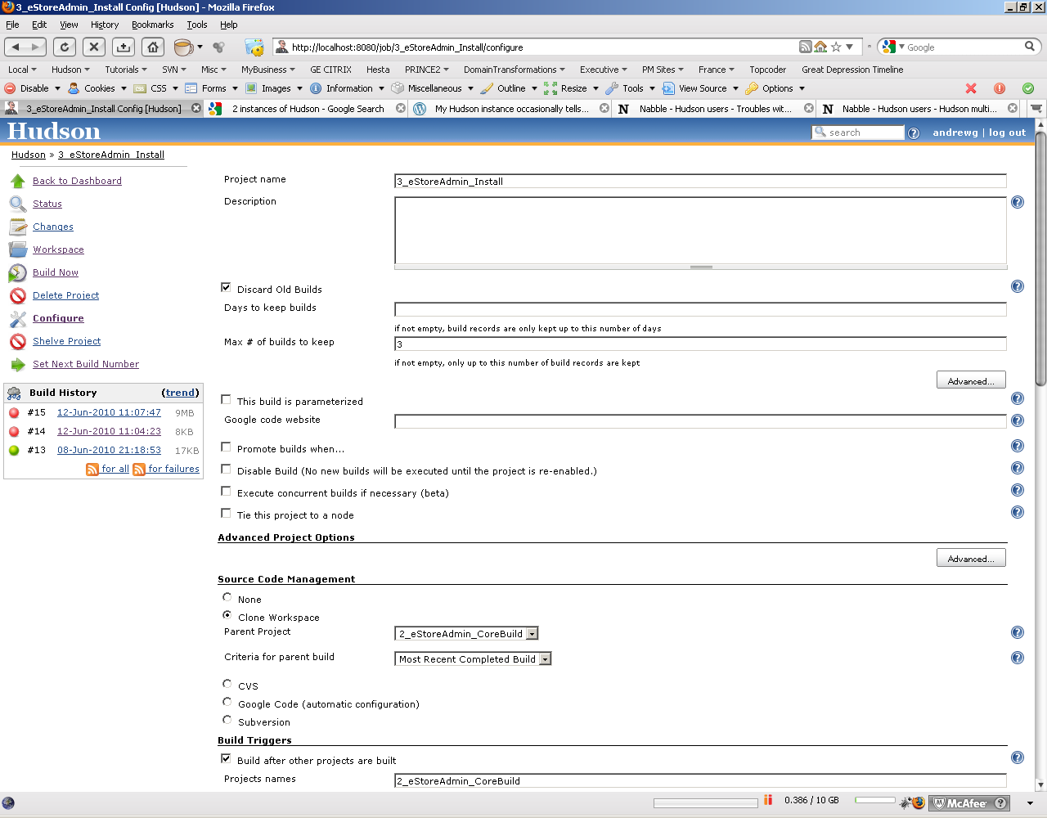

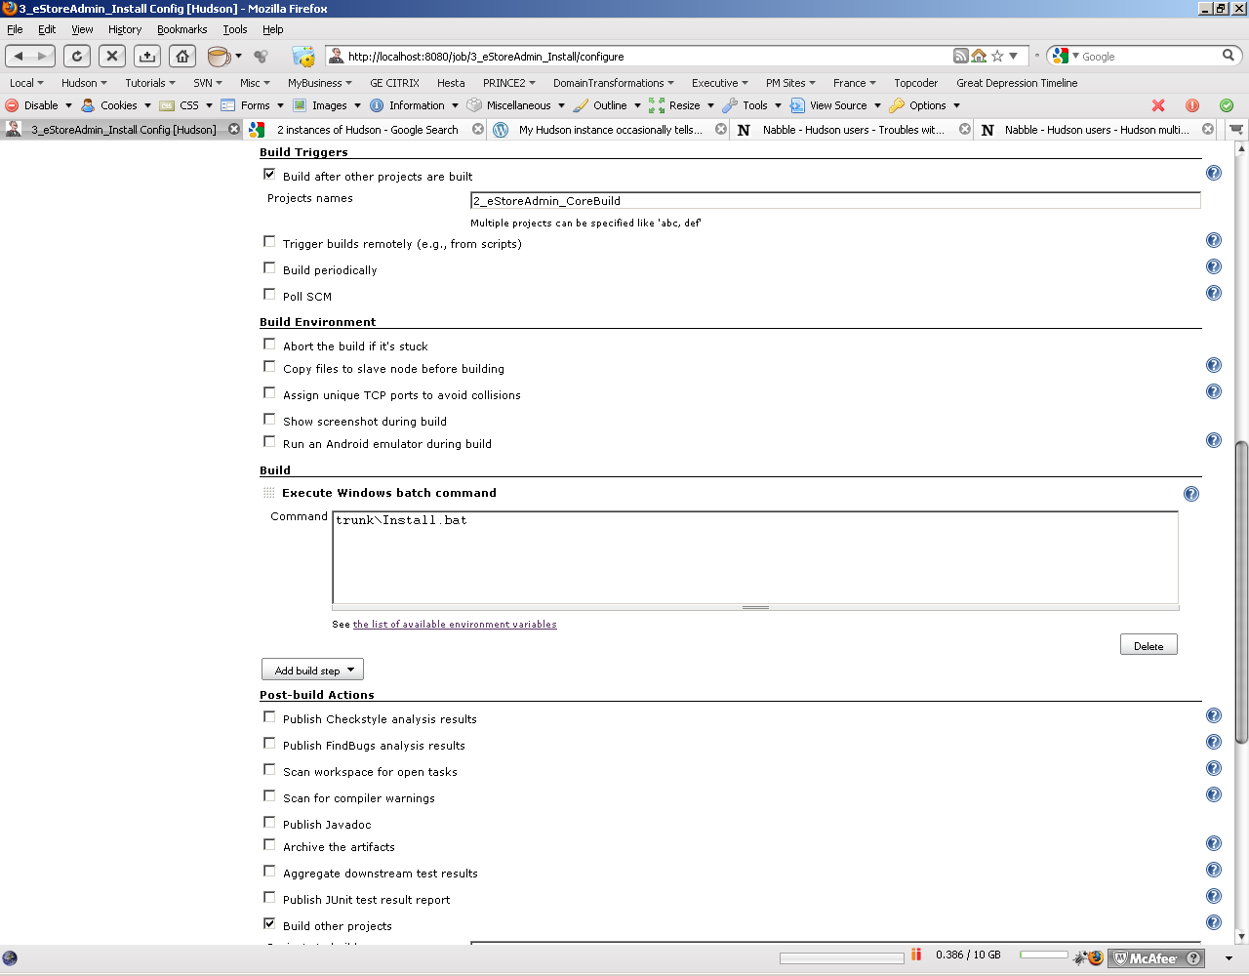

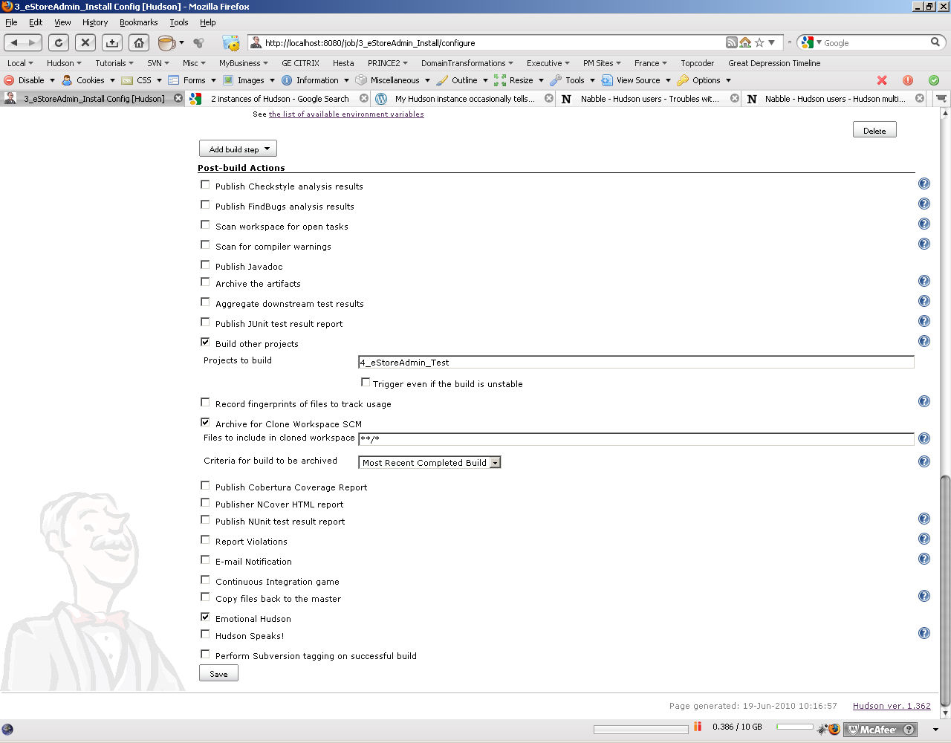

## 4_eStoreAdmin_Test

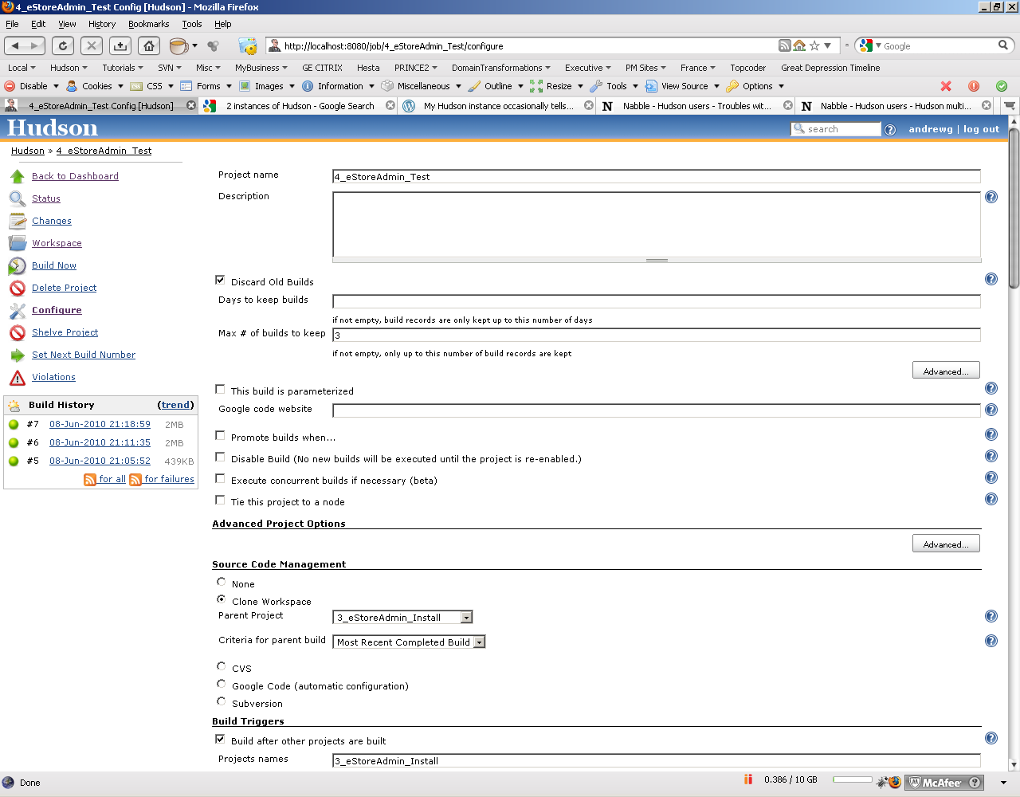

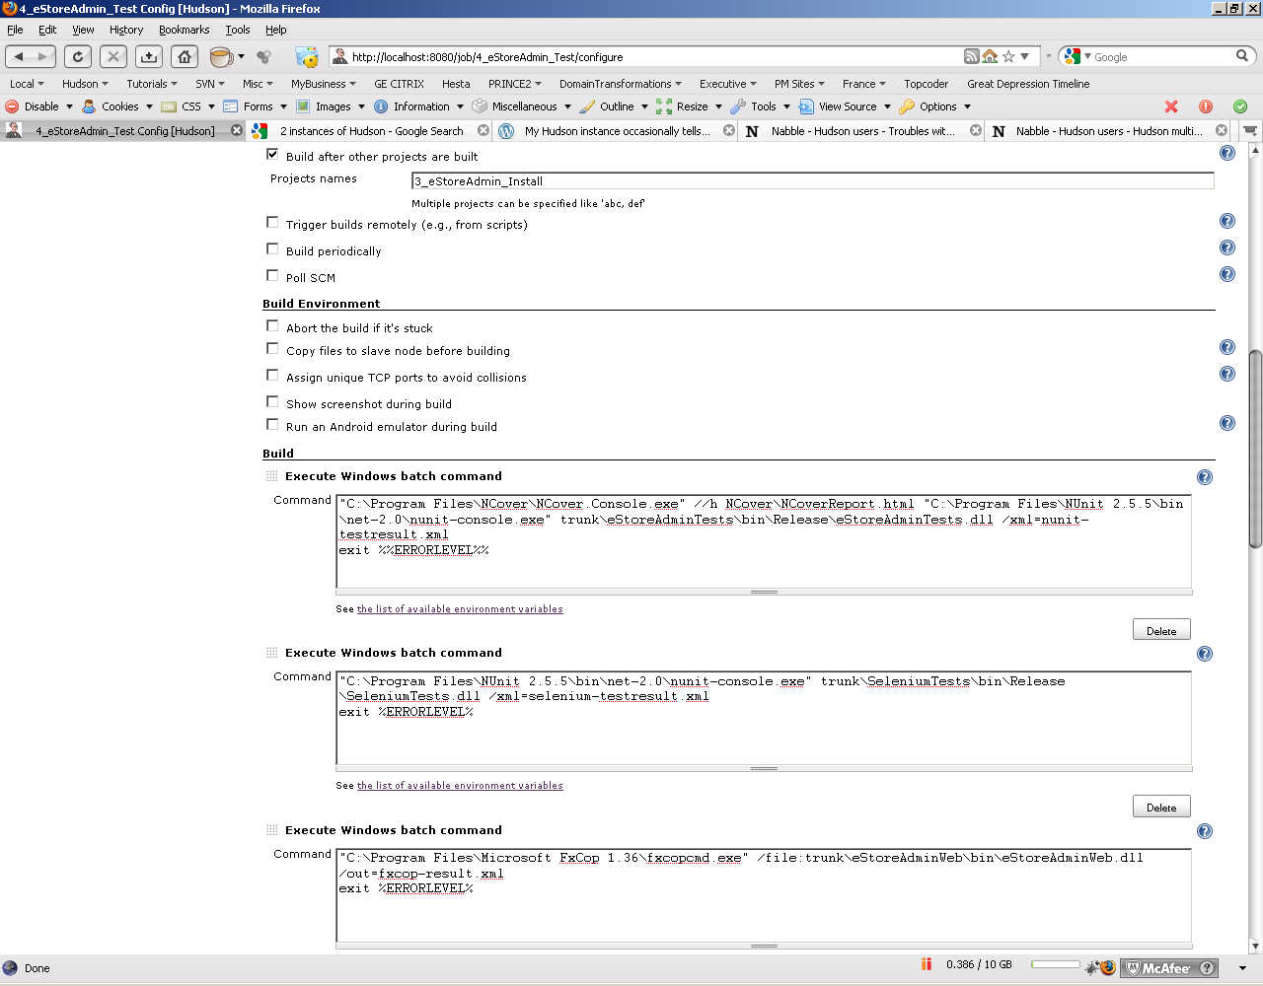 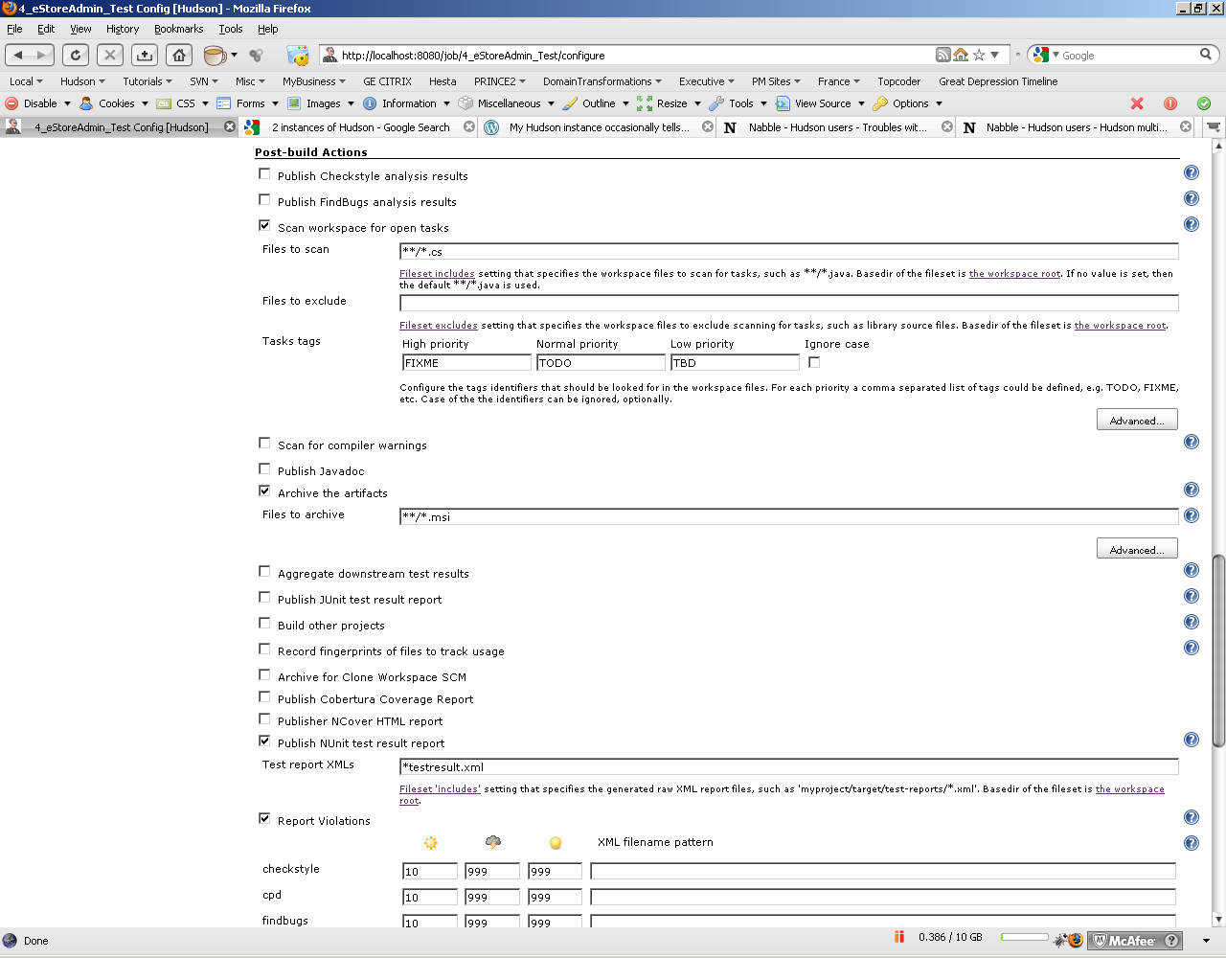 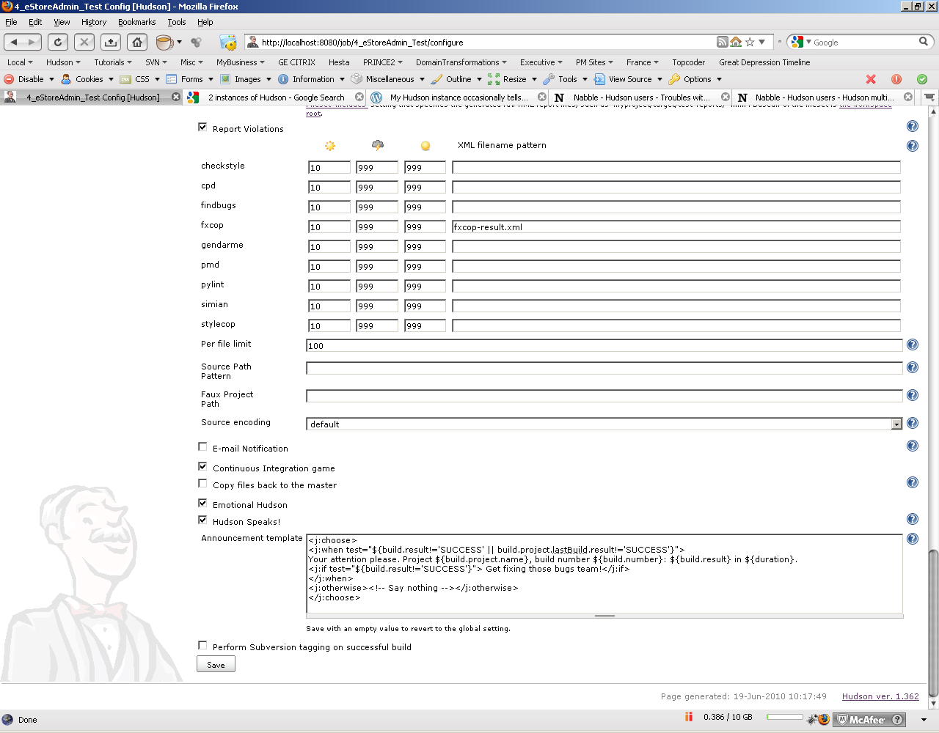

## ColorPicker

## 

## 

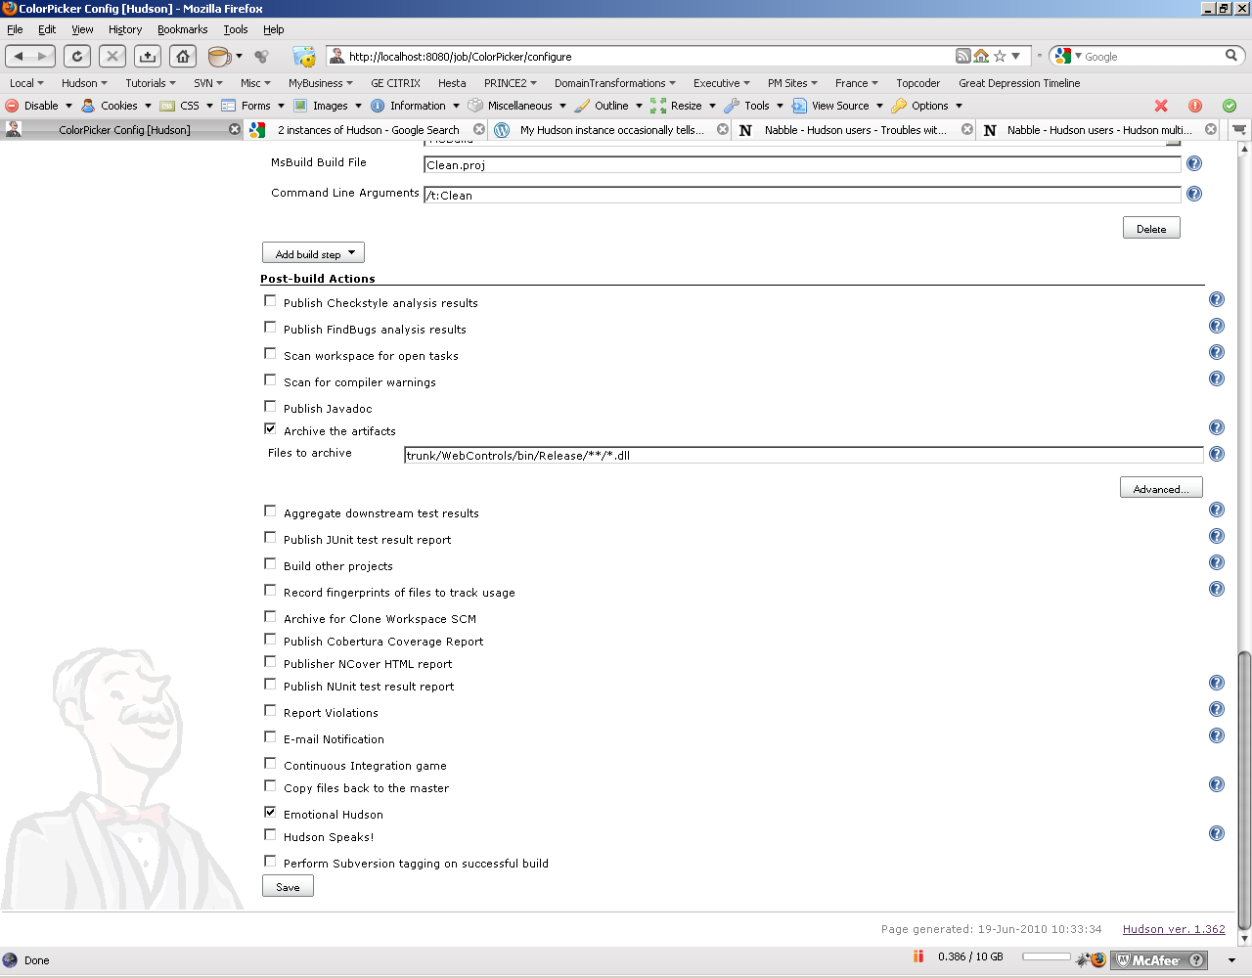

## eStoreCSharp

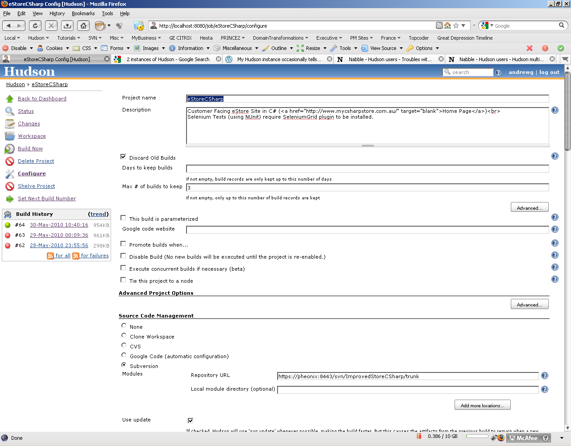

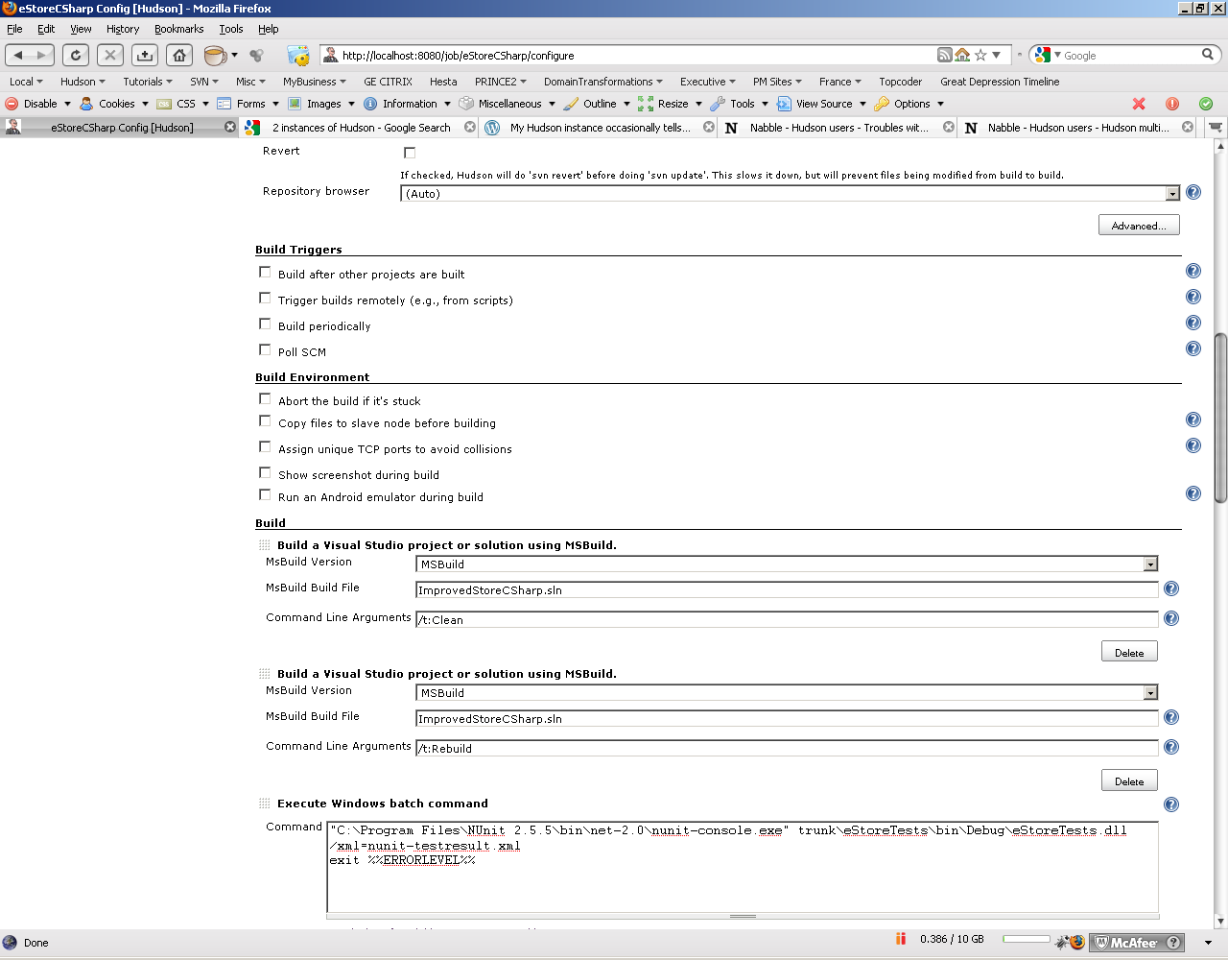

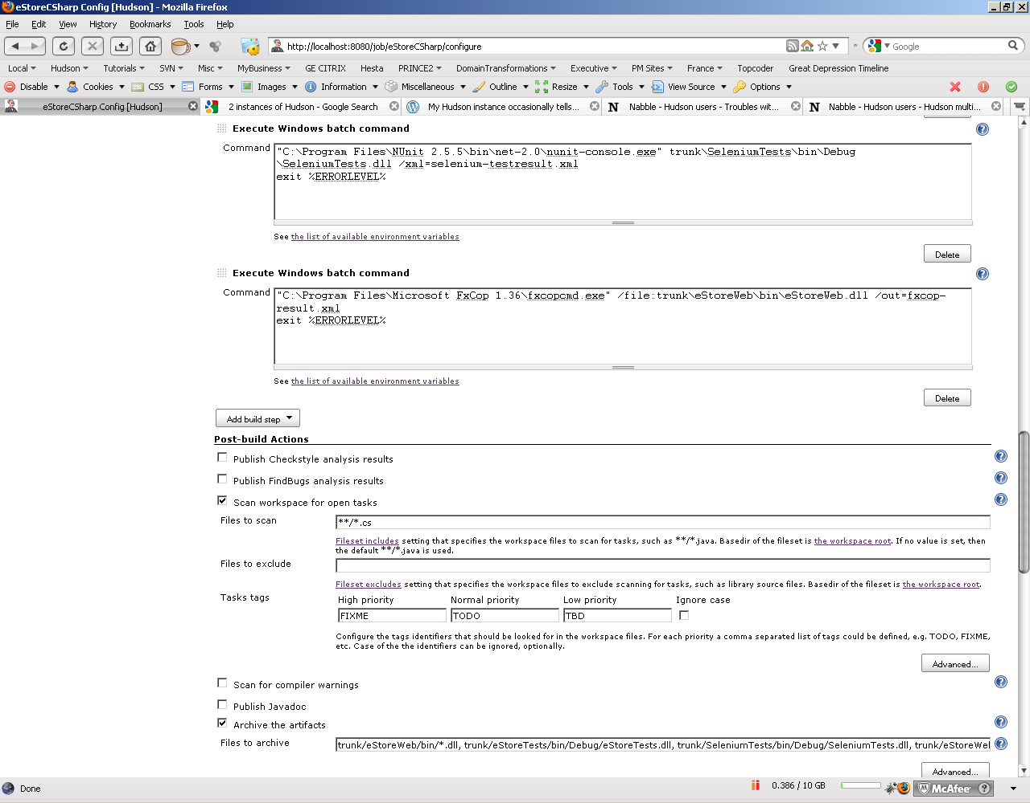

trunk/eStoreWeb/bin/*.dll, trunk/eStoreTests/bin/Debug/eStoreTests.dll, trunk/SeleniumTests/bin/Debug/SeleniumTests.dll, trunk/eStoreWeb/Web.config, **/*.aspx, **/*.ascx, **/*.skin, **/*.config, **/*.css, **/*.asax

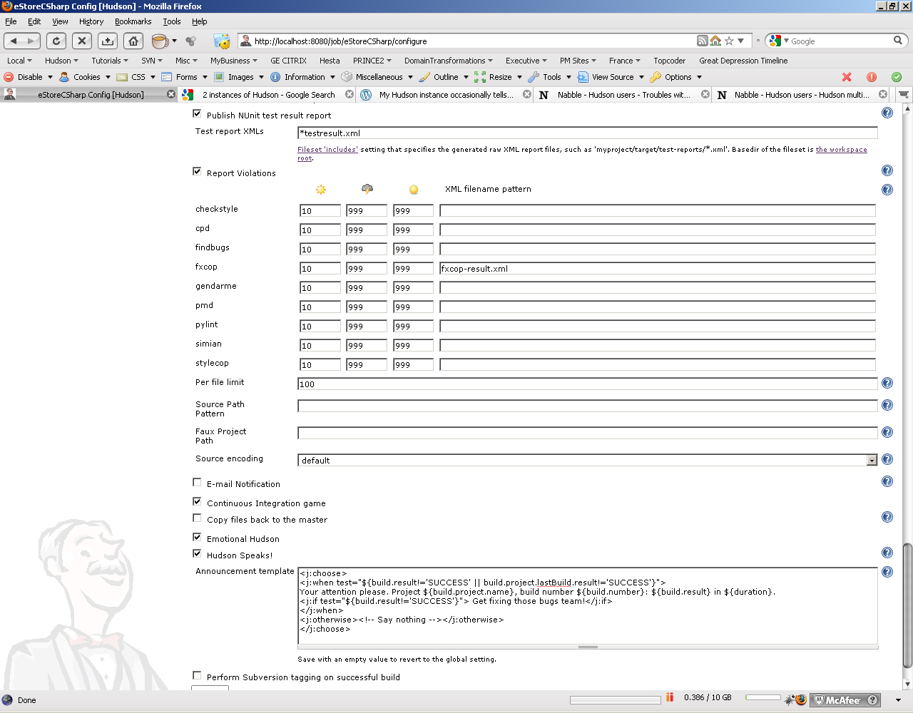

## FaceletsWARArchetype

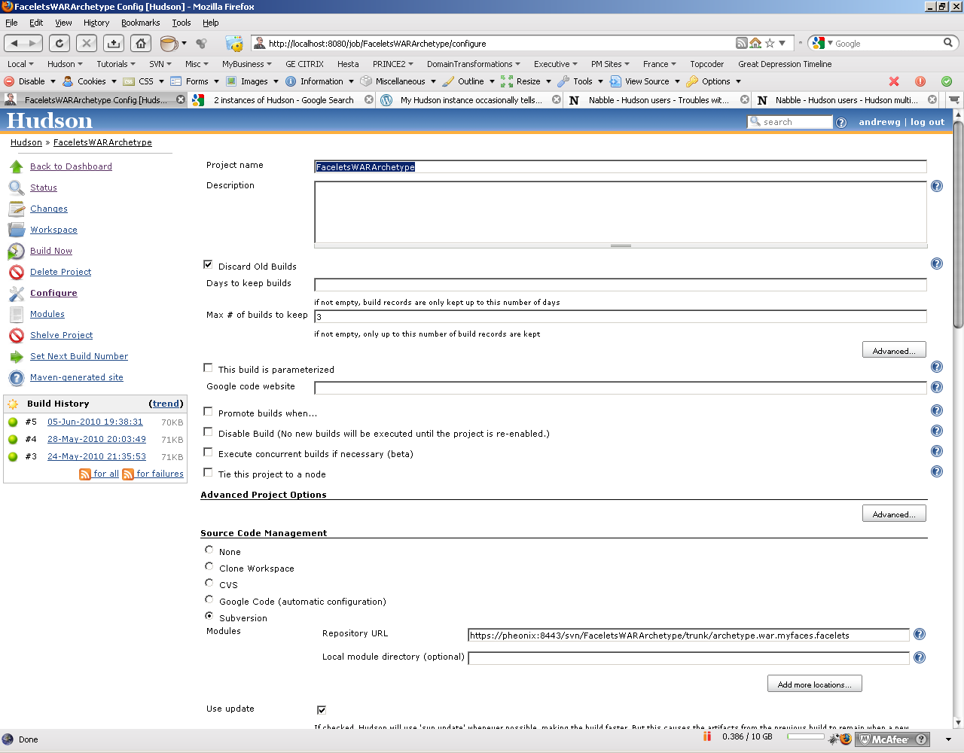

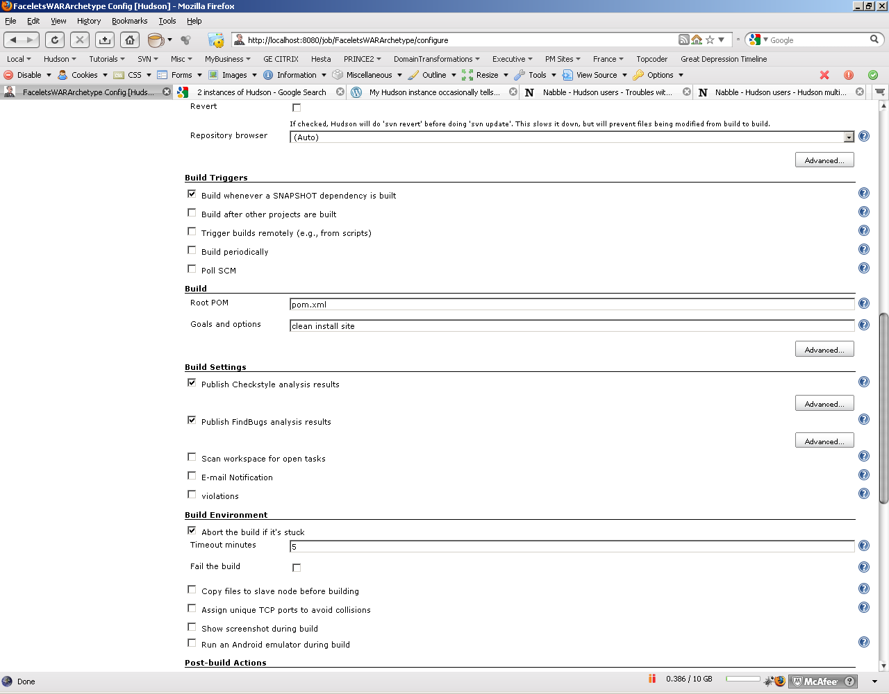

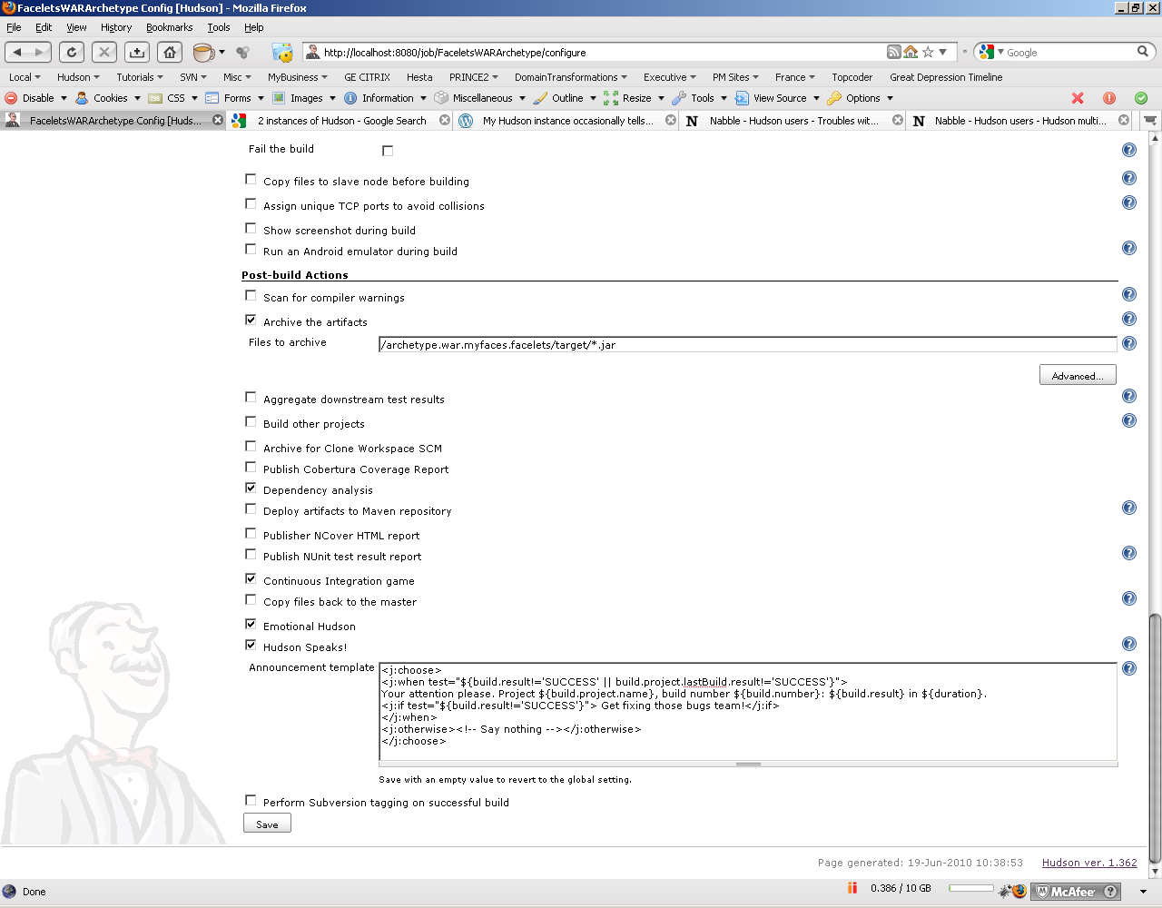

## FCKEditor

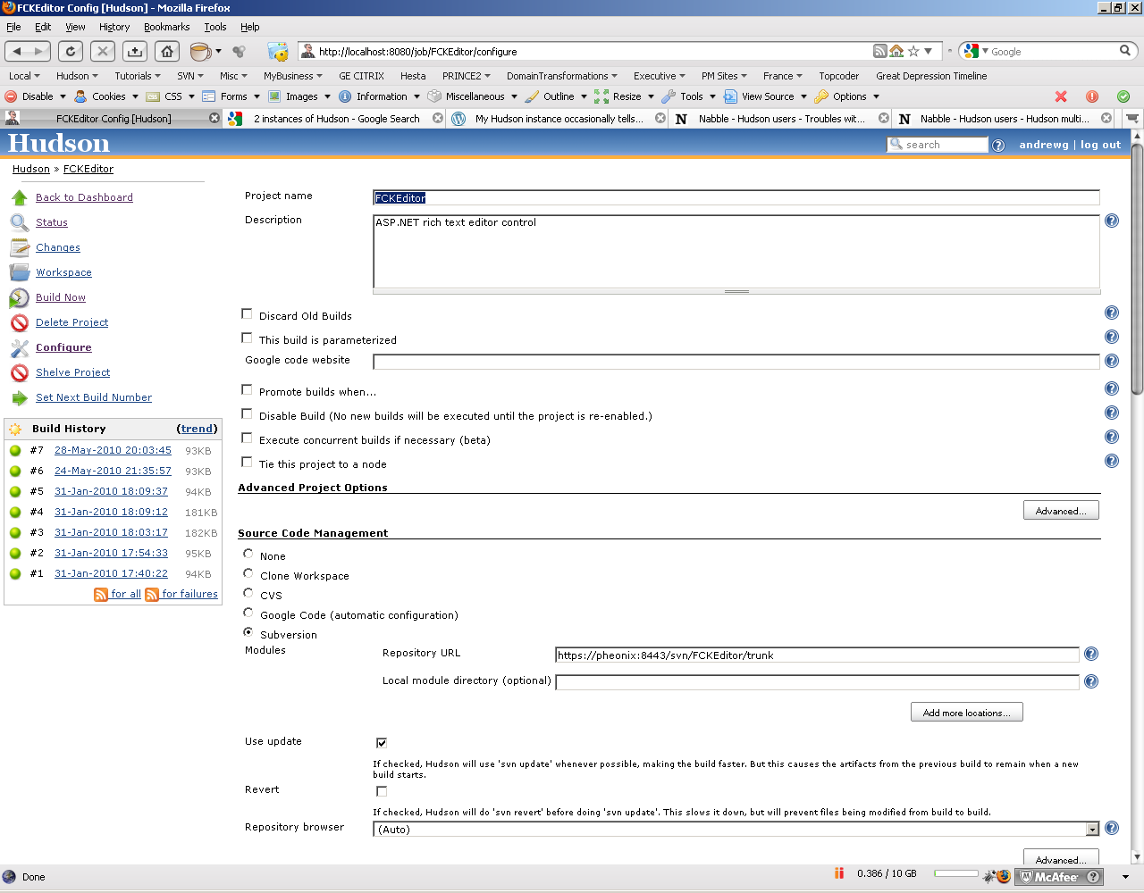

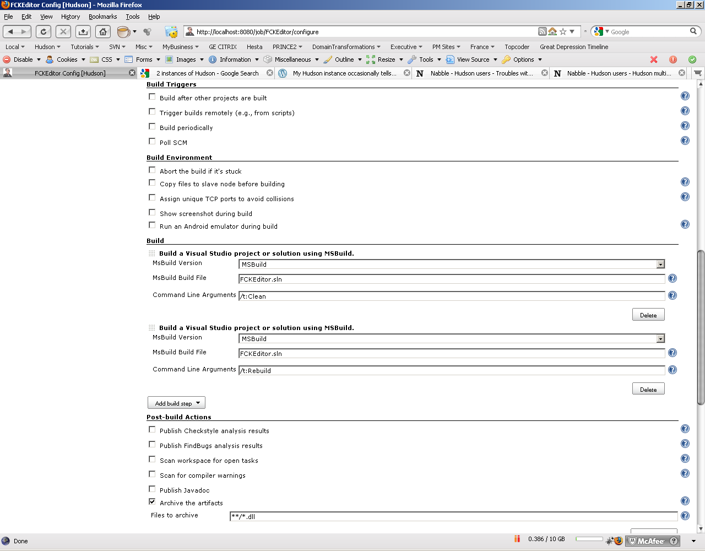

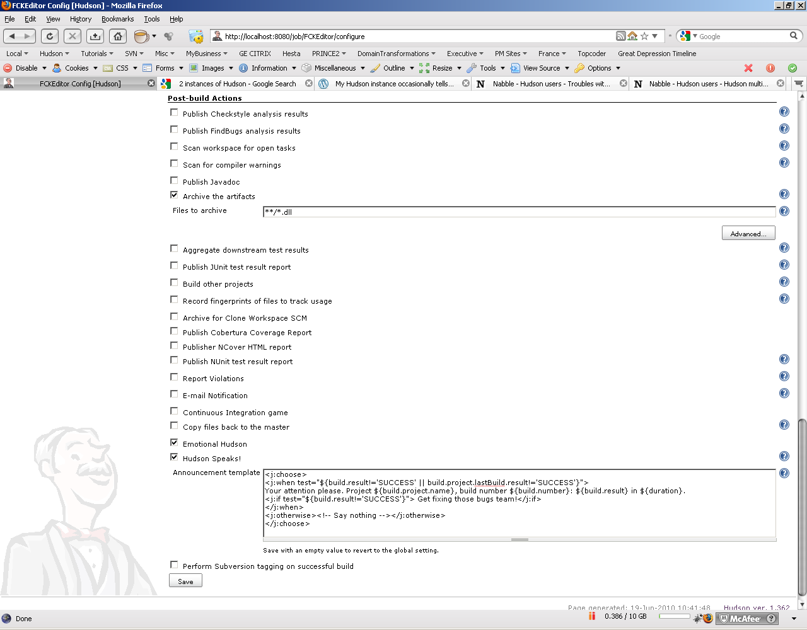

## RichTextEditor

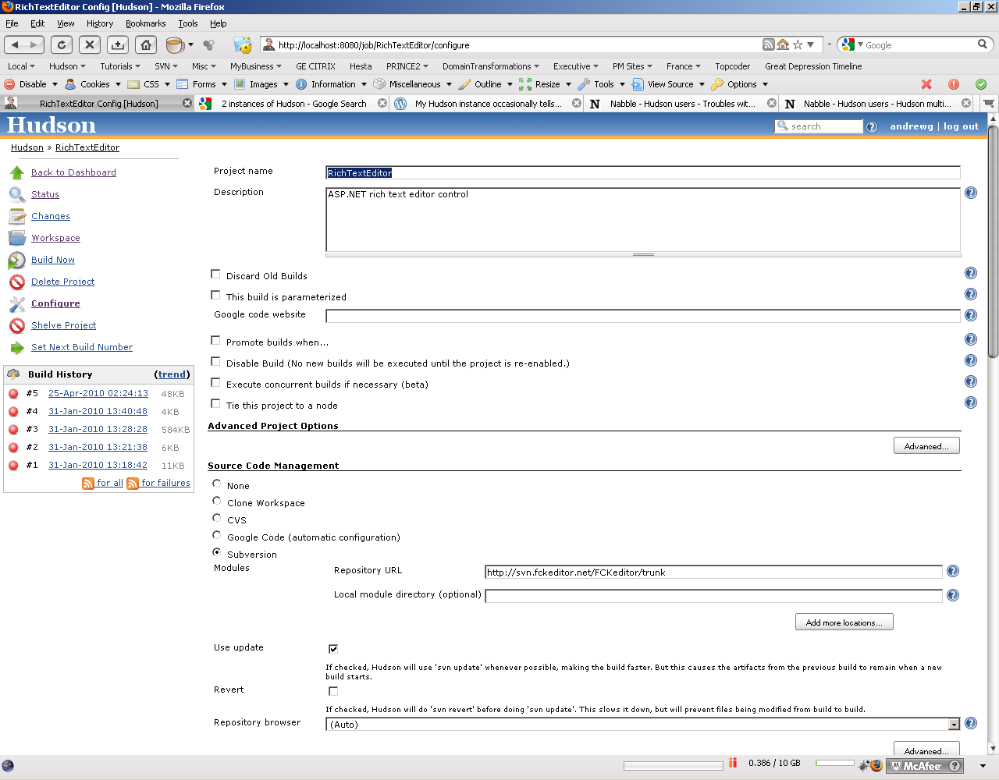

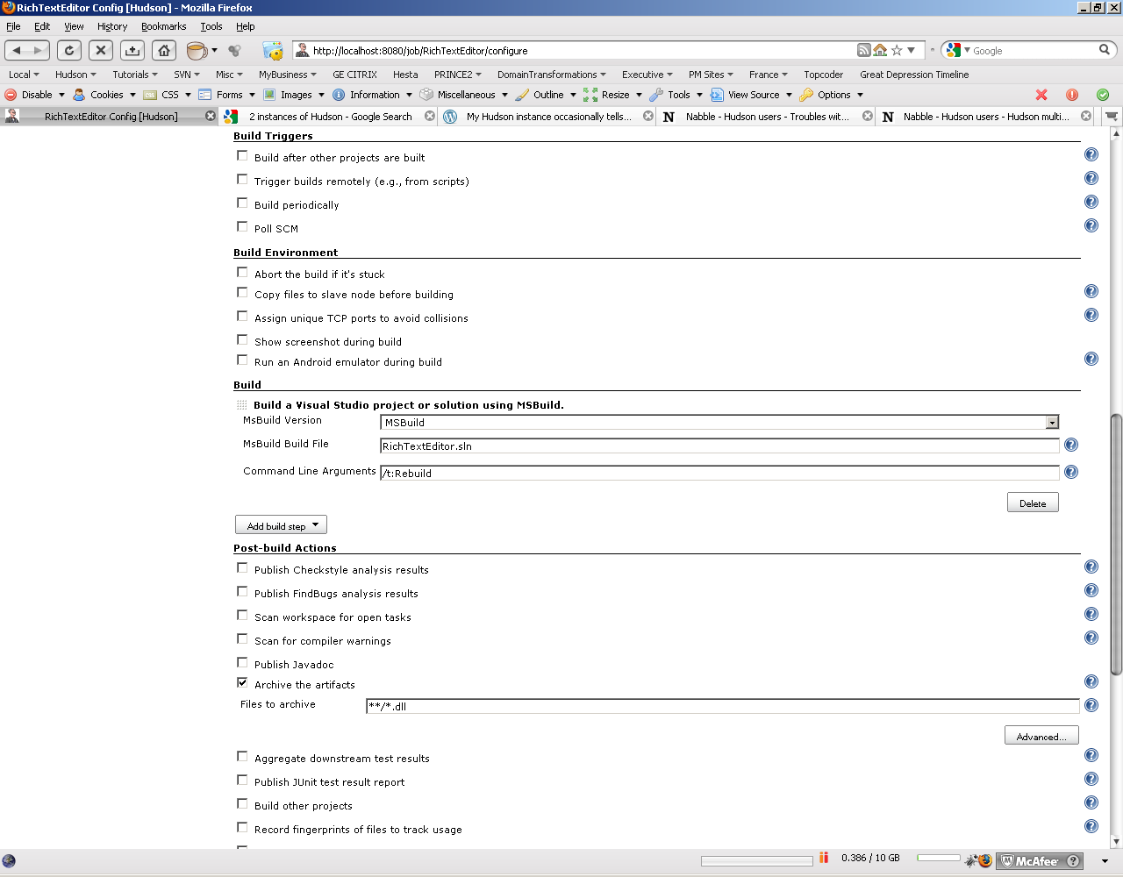

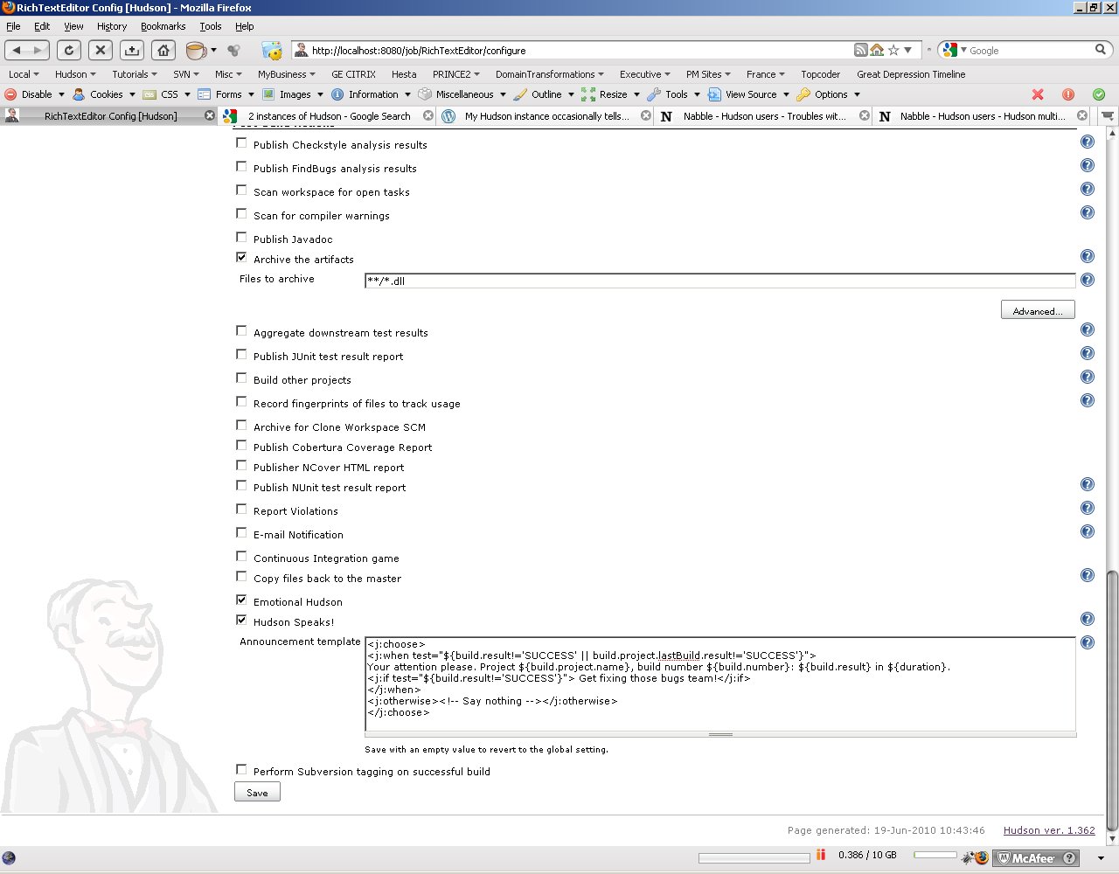

## selenium-rc

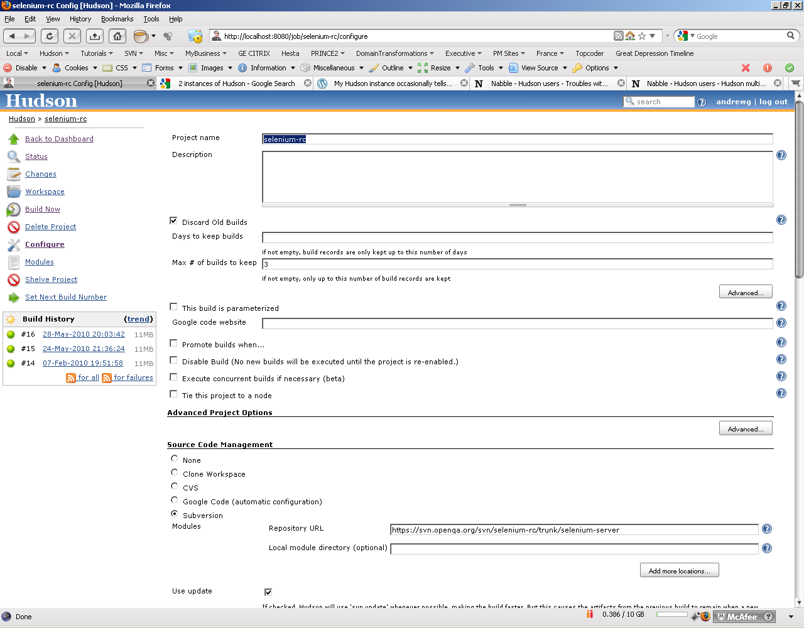

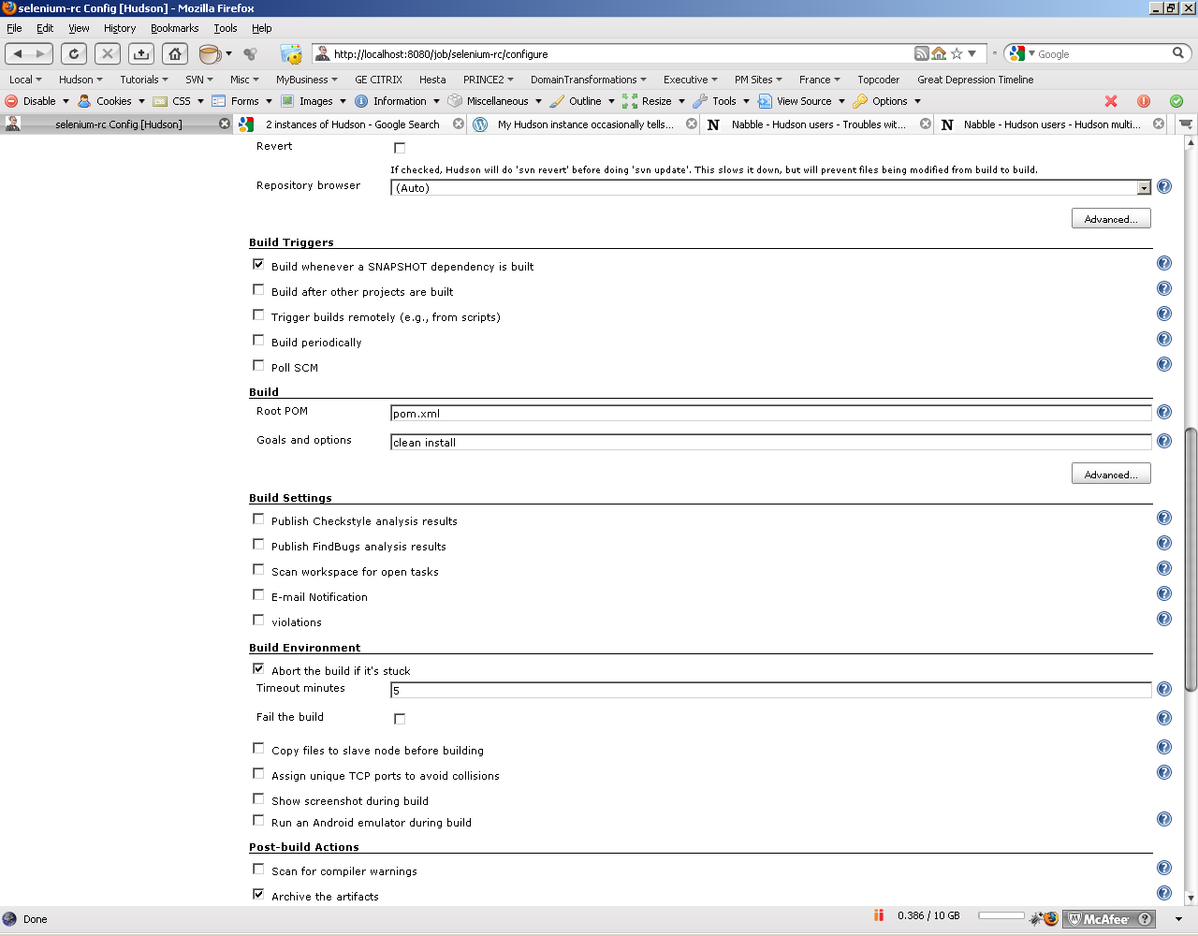

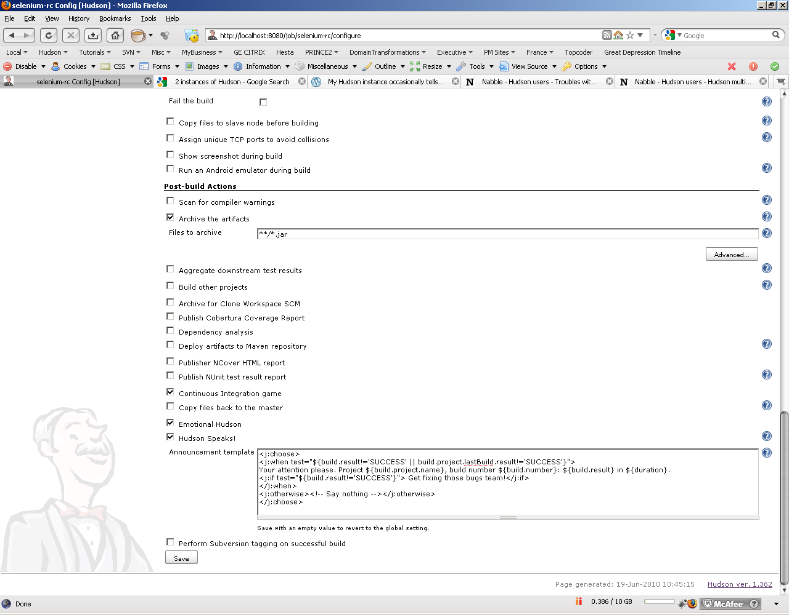

# Manage Nodes

